Humphrey’s Peak data:

Life Zone | Dominant Plant Species | 2019 Max Elevation (m) | 2099 Predicted Max Elevation (m)
Transition  (1800 – 2400 m) | Ponderosa pine | 2400
Canadian  (2400 – 2800 m) | Douglas fir | 2800
Hudsonian (2800 – 3500 m) | Engelmann spruce | 2500
Arctic-Alpine (3500 – 3850 m) | San Francisco Peaks ragwort | 3850

Mountain Feature | 2019 Elevation (m) | 2219 Predicted Elevation (m)
Timberline (elevation where no trees grow) | 3500

Predicted change in mean temperature between 2019 and 2099: 4-8°C (7-15°F)

The San Francisco Peaks (Humphrey’s Peak on the left):
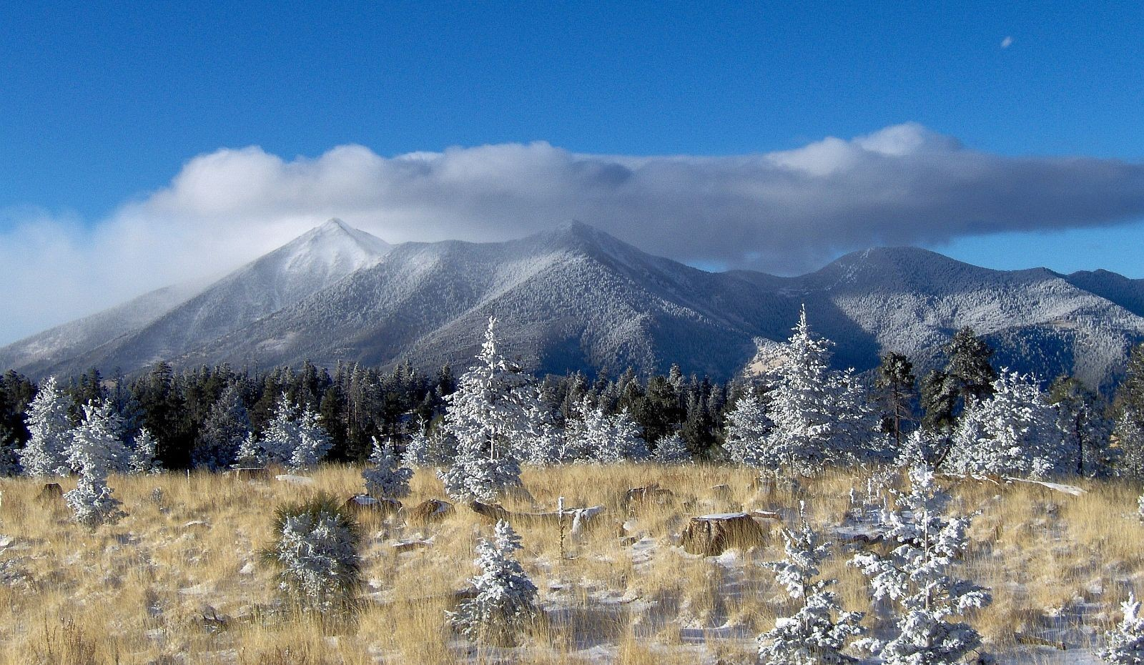

Humphrey’s Peak: Today and Future Predictions

Elevation (meters)
4000
2019
2099
3800
3600
3400
3200
3000
2800
2600
2400
2200
2000
1800

