Appendix 1
Pre-Semester Questions About Exam Anxiety

The following questions were asked regarding exam anxiety on a survey given at the beginning of the semester (prior to the beginning of classes).

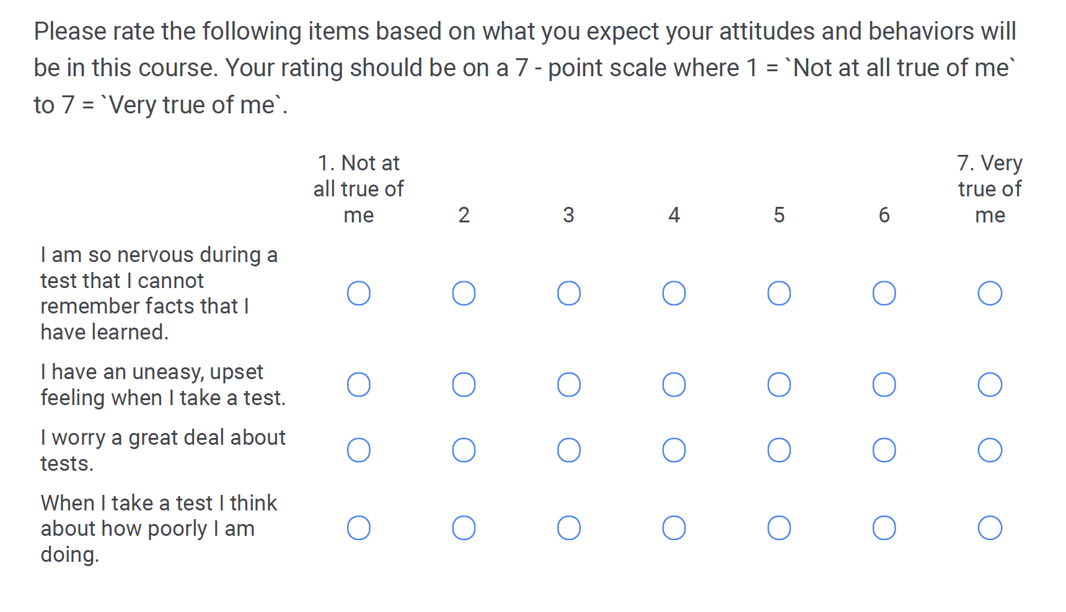

Appendix 2
Post-Exam Survey

You are now finished with the graded portion of the exam. Because we are interested in the way students respond to different exam formats, we would greatly appreciate your reflections on the following questions. You are welcome to omit any questions. Information from this will be kept confidential.

- I was so nervous during this test that I could not remember facts that I have learned.
- Strongly Agree
- Agree
- Neutral
- Disagree
- Strongly disagree

- I had an uneasy, upset feeling when I took this test.
- Strongly Agree
- Agree
- Neutral
- Disagree
- Strongly disagree

- I worried a great deal about this test.
  - Strongly Agree
  - Agree
  - Neutral
  - Disagree
  - Strongly disagree

- When I was taking this I was thinking about how poorly I was doing.
- Strongly Agree
- Agree
- Neutral
- Disagree
- Strongly disagree

