Appendix 1. Inter-item correlation matrix for all items on the Self-Efficacy Survey (SES) created using the psych package in R (Revelle, 2017; R Core Team, 2016). N=492
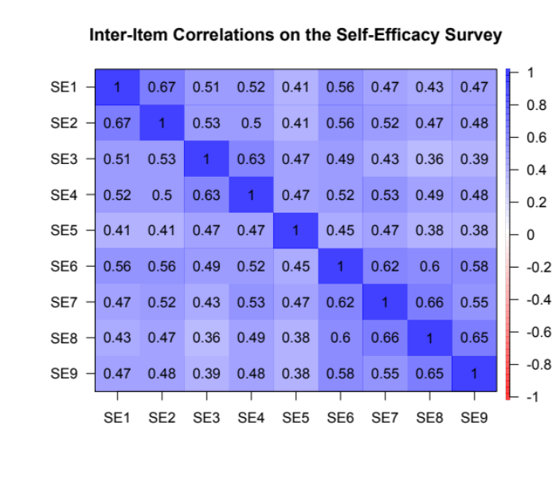
Appendix 2. Scree plot created from the parallel analysis of the SES data. Plot created using the psych package in R (Revelle, 2017; R Core Team, 2016). N=492

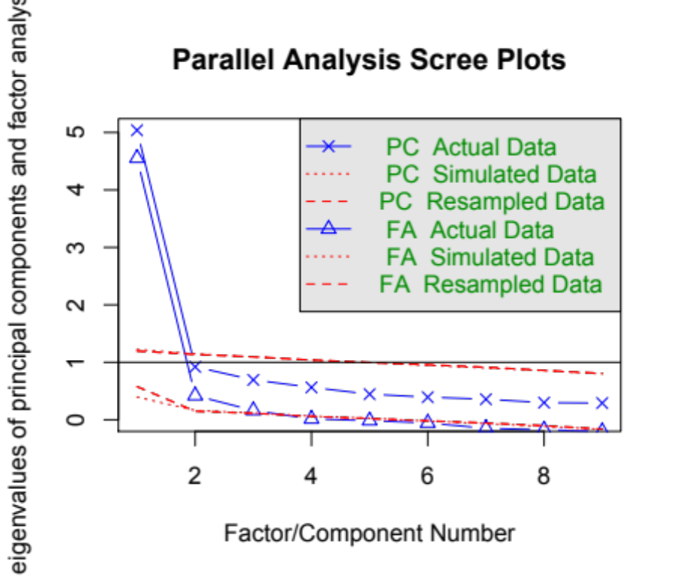

Appendix 3. Cronbach’s alpha for the 3 constructs of the SES survey. Table shows the raw alpha for each construct as well as the reliability of the construct if an item is dropped. For each construct, eliminating an item either lowers (ED, SL) or leaves the raw alpha unchanged (CO-item 5).

ED (items 1-2) Raw alpha = 0.80
Alpha if Item is Dropped
Item 1 | 0.67
Item 2 | 0.45
CO (items 3-5) Raw alpha = 0.76
Alpha if Item is Dropped
Item 3 | 0.62
Item 4 | 0.64
Item 5 | 0.76
SL (items 6-9) Raw alpha = 0.86
Alpha if Item is Dropped
Item 6 | 0.83
Item 7 | 0.82
Item 8 | 0.81
Item 9 | 0.84

Appendix 4. Histograms demonstrating the pre- and post-course responses for BIO1 (N=173) and BIO2 (N=149) students for A. item one on the Future Goals Survey - I intend to enroll in a master’s program in science, mathematics, or engineering [after I graduate]; B. item two on the Future Goals Survey - I intend to enroll in a Ph.D. program in science, mathematics, or engineering [after I graduate]; C. Item four on the Future Goals Survey - I intend to pursue certification to teach science or mathematics in a high school [after I graduate].

