Kangaroo metabolic energy: Day 3 of the Kangaroo Locomotion Case Study
Names:

Kangaroos use two different types of locomotion. Please watch the video provided of a young kangaroo using both types of locomotion. The first type of locomotion utilizes a distinctive gait for slow speeds (<6km/hr.) referred to as pentapedal locomotion. This mode utilizes both hind and forelimbs as the kangaroo stretches out, as well as a muscular tail that helps support the animal’s body weight while it repositions its hind legs to reset the cycle. At faster speeds, kangaroos switch to bipedal hopping, which relies on their muscular hind limbs to generate propulsion. As you analyze each type of locomotion, keep in mind its distinctive features such as: maneuverability – ability to quickly change direction, stability – resistance to tipping by maintaining center of mass over contact points with the ground, metabolic energy cost of transport – the number of Calories burned through metabolism per distance travelled, musculoskeletal biomechanics – how muscles, bone, and connective tissue produce movement.
Illustration of kangaroo pentapedal and bipedal hopping locomotion gaits. Chart of limb-ground contact patterns: LH: left hind leg; LF: left front leg; T: tail; RF: right front leg; RH: right hind leg
Questions:
1. If a kangaroo is traveling 4.2 km/hr, what type of locomotion will the kangaroo most likely use? What about at 15.0 km/hr?

2. What type of locomotion do you think provides the greatest stability during movement? Explain your reasoning.

3. What type of locomotion do you think provides the greatest maneuverability during movement? Explain your reasoning.

4. Which limbs seem to be most important for propulsion in pentapedal and bipedal hopping gaits? (Hint: use the duration of contact with ground to support your reasoning)

5. Compare and contrast the function of the tail in pentapedal and bipedal gaits of kangaroo locomotion. (Hint: observe the tail position in figure 1 and in the video provided)

Many organ systems must work together for animals to move through their environment. Muscles generate contraction forces, which pull on the skeletal structure via elastic tendons to produce limb movement. Other systems such as respiratory and circulatory systems provide oxygen, which is used in metabolism to produce the chemical energy needed for muscle contraction and active movement. Tendons serve a structural support role and a potential source of mechanical energy.
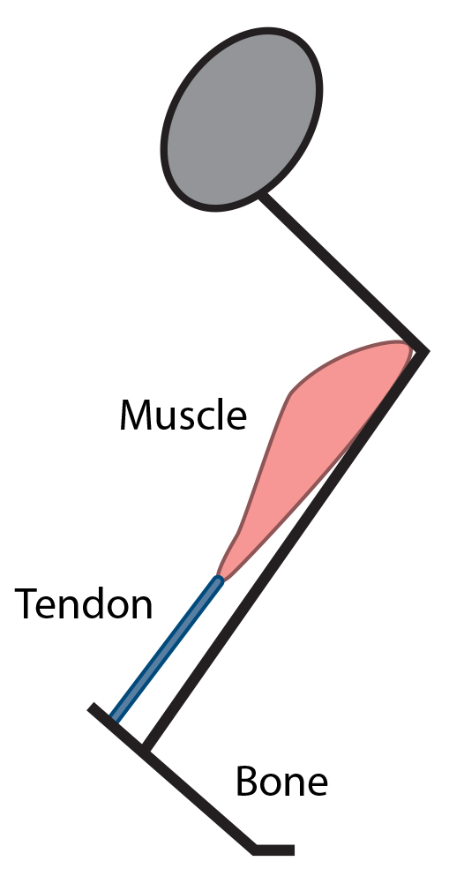
Rates of oxygen (O₂) consumption can be used to estimate metabolic energy consumption during exercise, since anaerobic metabolism does not significantly contribute to total energy production. For most mammals, oxygen consumption, and thus metabolic energy expenditure increases proportionally with speed. Animals increase the speed of locomotion by increasing the frequency of limb movement (stride frequency) and the distance each limb movement produces (stride length), although both features may not be increased to the same extent.
Figure adapted from data reported by Taylor et al., 1970.
Questions:
1. Increasing stride frequency requires significantly more metabolic energy expenditure, while increasing stride length does not significantly affect metabolic demand. How do you think muscle activity and tendon function contribute to increasing stride frequency and stride length? Explain your reasoning.

2. Using the graph above, what do you think the relative importance of increasing stride frequency and stride length is for increasing speed by a four-legged mammal (dog)? Explain your reasoning.

Kangaroos use a metabolically expensive pentapedal gait at slow speeds. However, in contrast to other mammals, metabolic energy expenditure does not increase proportionally with speed. At higher speeds, kangaroos switch to a hopping bipedal gait, which results in oxygen consumption slightly decreasing with increasing speed. Kangaroos have been observed to travel at sustained speeds of 40 km/hr with bursts of speed up to 65 km/hr.
Figure adapted from data reported by Dawson and Taylor, 1973.
3. Explain why you think the kangaroo transitions from pentapedal to bipedal hopping around the 6 – 7 km/hr speed range. (Hint: If the kangaroo continued to use pentapedal locomotion at higher speeds, what would the oxygen consumption vs. speed graph look like?)

4. Compare the trends of oxygen consumption for pentapedal and bipedal hopping gaits of kangaroos with the trends found in a dog of similar size. Using the graphs above, explain how you think kangaroos alter stride frequency and stride length in each locomotion gait to increase speed.

5. Why do you think the rate of metabolic energy demand in kangaroos remains constant or slightly decreases with increasing speed for bipedal hopping locomotion? Does the kangaroo use other source(s) of energy to increase speed? (Hint: refer to your previous data analysis and comparison of a ball bouncing and kangaroo hopping.)

6. Kangaroos are unique in that increasing speed can be uncoupled from metabolic demand. What tissue type allows the kangaroo to accomplish this? Explain your reasoning.

Extension Questions:
Kangaroos are grazing animals, which spend much more time moving with a slow pentapedal gait than hopping quickly. Yet, the anatomy of a kangaroo seems to have been adapted for metabolically efficient hopping locomotion with the development of large hind limbs.
1. What evolutionary advantages do you think have been selected for in the development of the kangaroo’s anatomy as it relates to locomotion? Discuss both locomotion gaits.

2. Would you expect a kangaroo ancestor that lived in lush jungles with plentiful food available to develop similar locomotion gaits? Explain your reasoning.

