Amelia Earhart
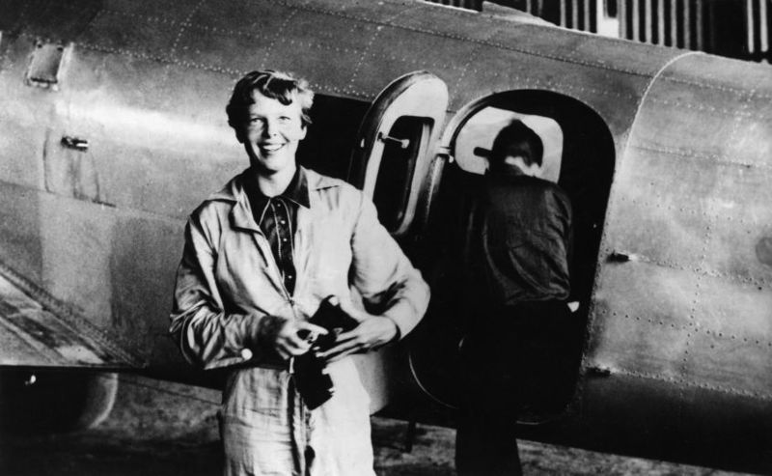
Amelia Earhart in front on her plane, the 10E Electra Electra.

Amelia Earhart was an American aviator who was the first woman to fly a plane across the Atlantic Ocean all by herself. She broke many records for airplane travel during her lifetime. Amelia disappeared in the South Pacific Ocean in July 1937 while trying to fly her plane named Electra around the world with her navigator Fred Noonan. She was never found and was declared dead on January 5, 1939.
Amelia Earhart was born on July 24, 1897 in Atchison, Kansas. From a very young age, and encouraged by her parents, she was interested in activities that were usually done by boys like playing football, fishing and baseball. After paying a pilot a dollar for a 10-minute airplane ride she decided to become a pilot in a field that was at the time mostly occupied by boys. After her first ride, she wrote, "By the time I had gotten two or three hundred feet off the ground, I knew I had to fly."
Neta Snook, the first woman to graduate from the Curtiss School of Aviation, taught Amelia how to fly between 1921 and 1922. Amelia earned her pilot’s license from the Federation Aeronatique Internationale in October of 1922. Her record setting days had just began! On October 22. 1922, Amelia set a women’s altitude record of 14, 000 (or 4, 200) in a plane called a Kinner Canary which is an open-cockpit, single-engine biplane.
Amelia co-founded an organization, called the Ninety-Nines, whose goal it was to advance women's participation and opportunities in aviation. The Ninety-nines included 99 charter members, representing 99 of the 117 licensed women pilots in the United States at the time. Amelia continued setting records. On July 6, 1930, she set a woman's speed record of 181 miles per hour in a Lockheed Vega, a single-engine monoplane. On April 8, 1931 she set an altitude record of 18,451 feet.

First Solo Atlantic Flight
Amelia Earhart set out on May 20, 1932 to fly solo across the Atlantic Ocean. She took off from Newfoundland, Canada at 7:12 on May 20. Her flight was filled with danger, including dropping 3000 feet in altitude and going into a spin, which she pulled out of, and flames coming out of the exhaust manifold. She arrived in Ireland after flying 2, 026 miles in 15 hours and 18 minutes. The flight was the second solo flight across the Atlantic and the longest nonstop flight by a woman. She received two awards for her flying accomplishment, the National Geographic Society Medal on June 21, 1932, for her achievement from President Herbert Hoover, and the U.S. Congress awarded her the Distinguished Flying Cross, the first woman to receive such an honor. Amelia Earhart's accomplishment meant a great deal to the entire world, but especially to women, for it demonstrated that women could set their own course in aviation and other fields.

Flight Around the World
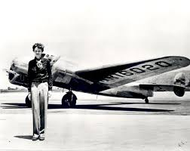
Amelia Earhart wanted to be the first person (of either gender) to fly around the world at its widest, close to the equator. To attempt that feat, she acquired one of the most advanced planes at the time: a Lockheed Model 10E Electra. The Electra was an all-metal, two engine plane that was fitted with extra fuel tanks for long flights. Her first attempt started on March 17, 1937 in Oakland, California but ended with a blown out tire in Hawaii that caused damage needing repair. On May 20 she started again with a flight plan from Oakland to Miami, Florida. That flight was also unsuccessful because of mechanical problems.
Finally, on June 1, 1937, Amelia and her navigator Fred Noonan set out with a repaired plane. She flew from Oakland to Miami and from Miami to Puerto Rico. Right before taking off on this leg of the flight, Earhart was quoted as saying, "I have a feeling there is just about one more good flight left in my system and I hope this trip is it. Anyway, when I have finished this job, I mean to give up long-distance 'stunt' flying."

Disappearance
Amelia made the front page of newspapers around the world as her journal continued. Throughout her trip she sent back reports of the land and people that she visited. Amelia and Fred landed in Lae, New Guinea on June 30, 1937 after traveling 22,000 miles with 7,000 miles left to go. On July 1, they set out for their next destination, Howland Island, a tiny island in the Pacific Ocean, 2,556 miles away. Amelia and her plane apparently ran into a severe storm. She was in radio transmission with a crew of the ground, but she never reached Howland Island. A large search party looked for her for many weeks, but her plane was never found.

The most commonly accepted theory for her disappearance on July 2, 1937 is that she got lost, ran out of gas, and went down somewhere in the Pacific Ocean.
Amelia Earhart was only 39 years of age when she disappeared. In her short life she accomplished a great deal. Throughout her life she was a role model for women and demonstrated courage, tenacity, integrity and a free spirit. In her lifetime she used her fame to advance women’s rights. She inspired women to know that they could seek out different roles, occupations and pursuits.
References
Amelia Earhart. Retrieved June 14, 2018 from https://kids.kiddle.co/Amelia_Earhart

Gilpin, C. (2013). National Geographic Kids Readers: Amelia Earhart. National Geographic Kids. Washington, D. C.

All photo credits from public domain.

