Bivalve and Gastropod Anatomy

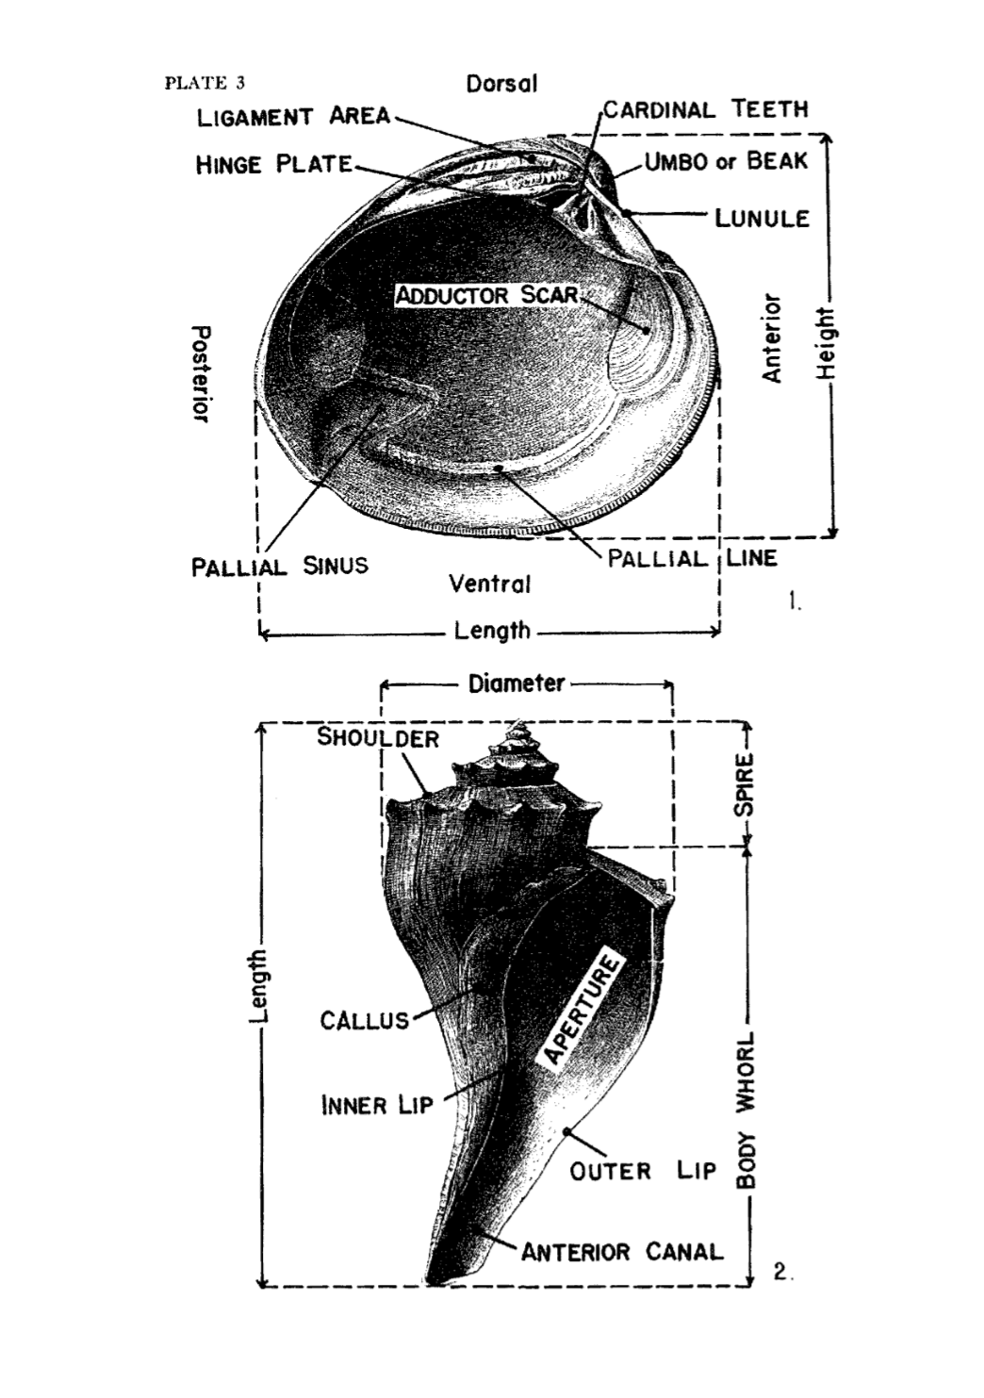

Common Miocene Bivalves

|  |  |  |
| --- | --- | --- |
| Scallop shell |  | Geoduct |
| Arc clam | Lucine clam  A picture containing animal, invertebrate, mollusk  Description automatically generatedl | Quahog clam |
| Venus clam | Cardita clam  A picture containing invertebrate, animal, mollusk  Description automatically generated  Astarte clam | Pearl Oyster (Tree oyster) |

Common Miocene Gastropods

|  |  |  |
| --- | --- | --- |
|  | Whelk  Buccinofusus | Moon snail |
| Channeled whelk | Ecphora    Turret snail | Cup-and-saucer shell   |

Other Miocene Fossils

|  |  |
| --- | --- |
| Coral    Shark teeth-variety of species | Barnacle  Ray dental plate    Crab claw |
| sand dollar fragments | Sand dollar fragments |