February 16, 2020
Hi Friends,
I am writing to share some super cool pictures I took at the beach. While I was walking along I saw what looked like pieces of coral in the cliff. I thought that was really weird because we don’t have any coral reefs near where I live in Maryland. I asked myself ‘why would there be coral in a cliff?’ I wanted to find out more, so I collected a bunch of treasures from the sand. I know it is never safe to dig in the cliffs so I made sure to get my collection from other places along the shore.
After a few trips to the beach I have a lot of evidence, but I don’t know what these things are or what they can tell me. I washed all my pieces of coral, shells, and teeth and then took pictures. Can each of you help me figure out what is going on here?
Your friend,
Maya
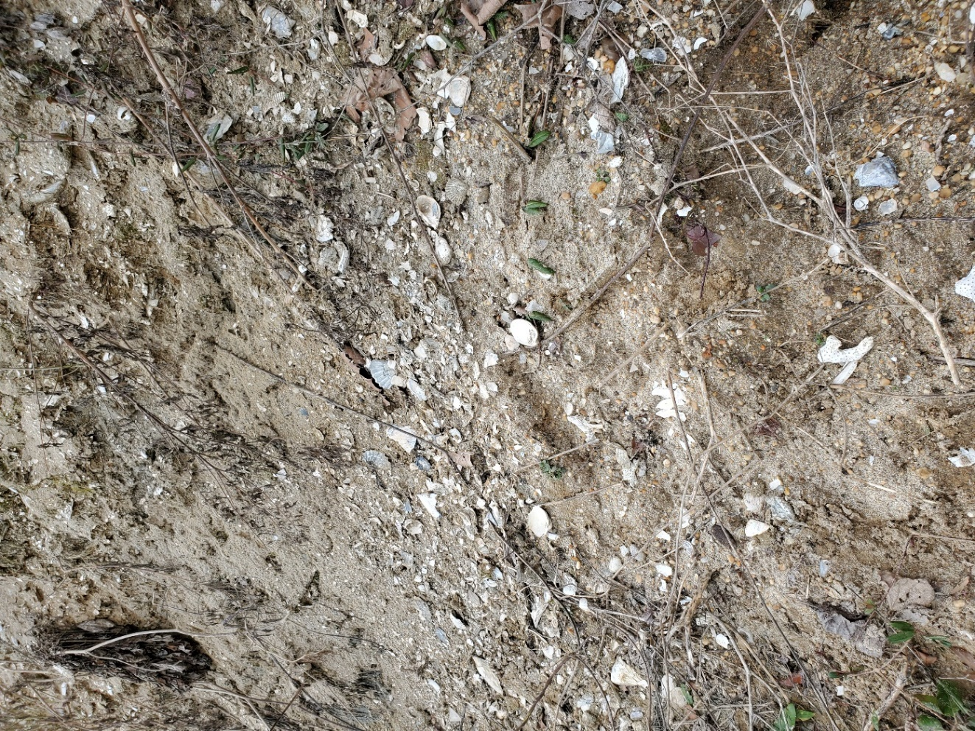
Hi friends, here is a picture I took of the cliff from up close. Can you find what I think looks like a piece of coral?
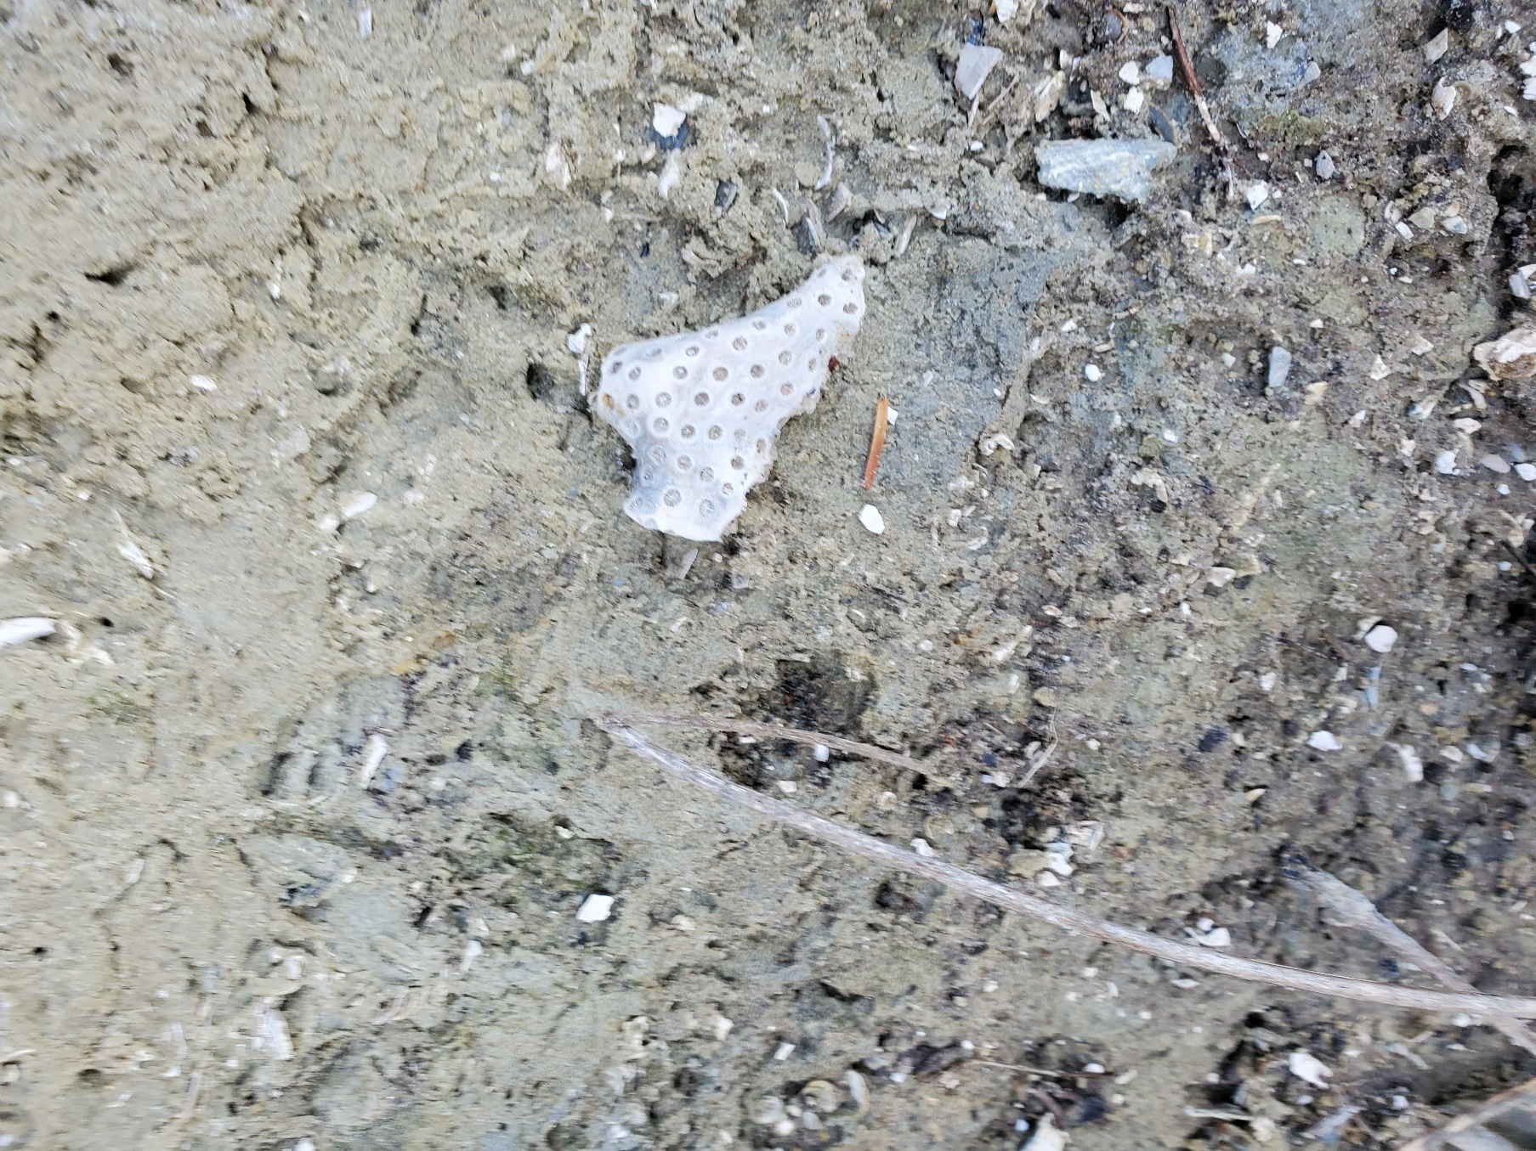
Can you see what I mean? Doesn’t this look like coral? Why would it be in the cliff?
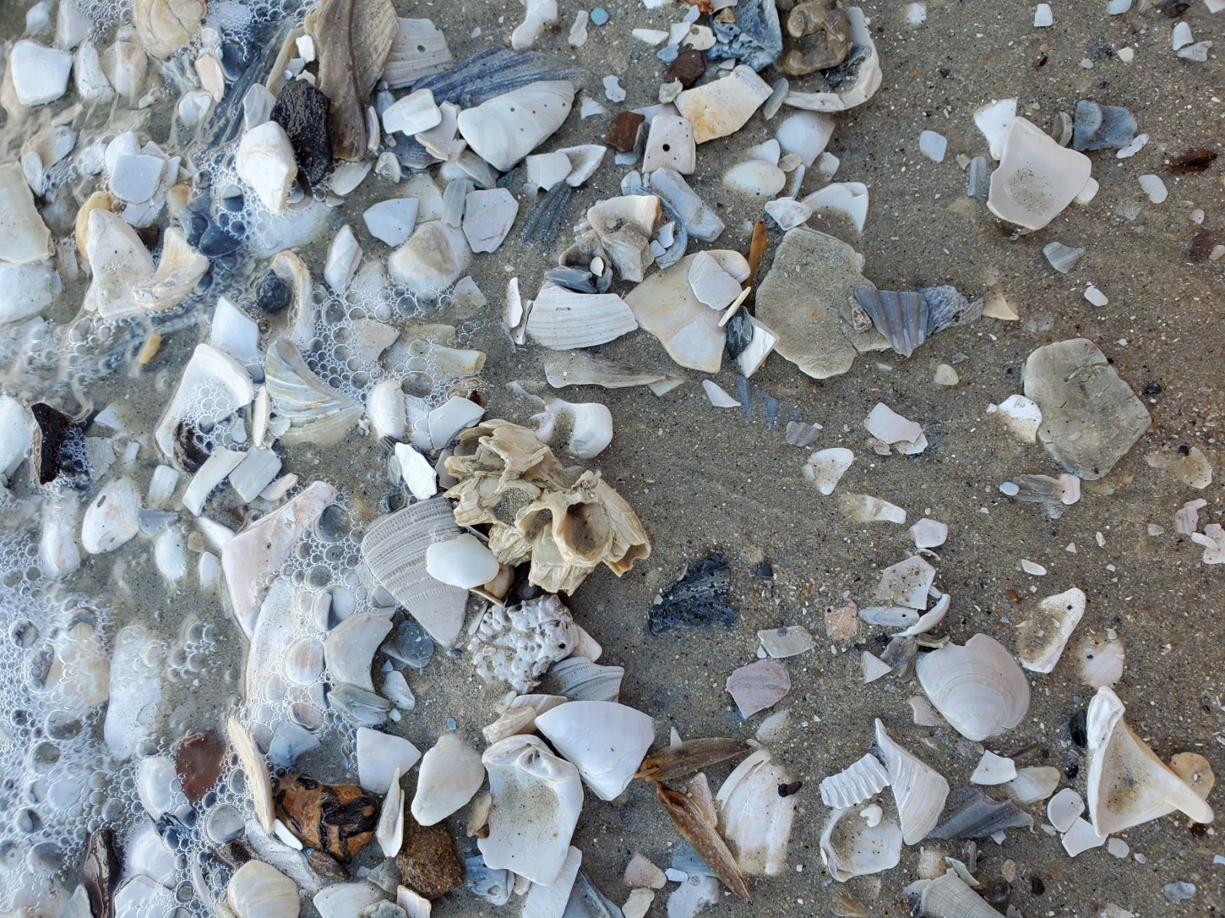
Here is what it looks like a the water’s edge. Sometimes I pick up shells and other cool pieces here.

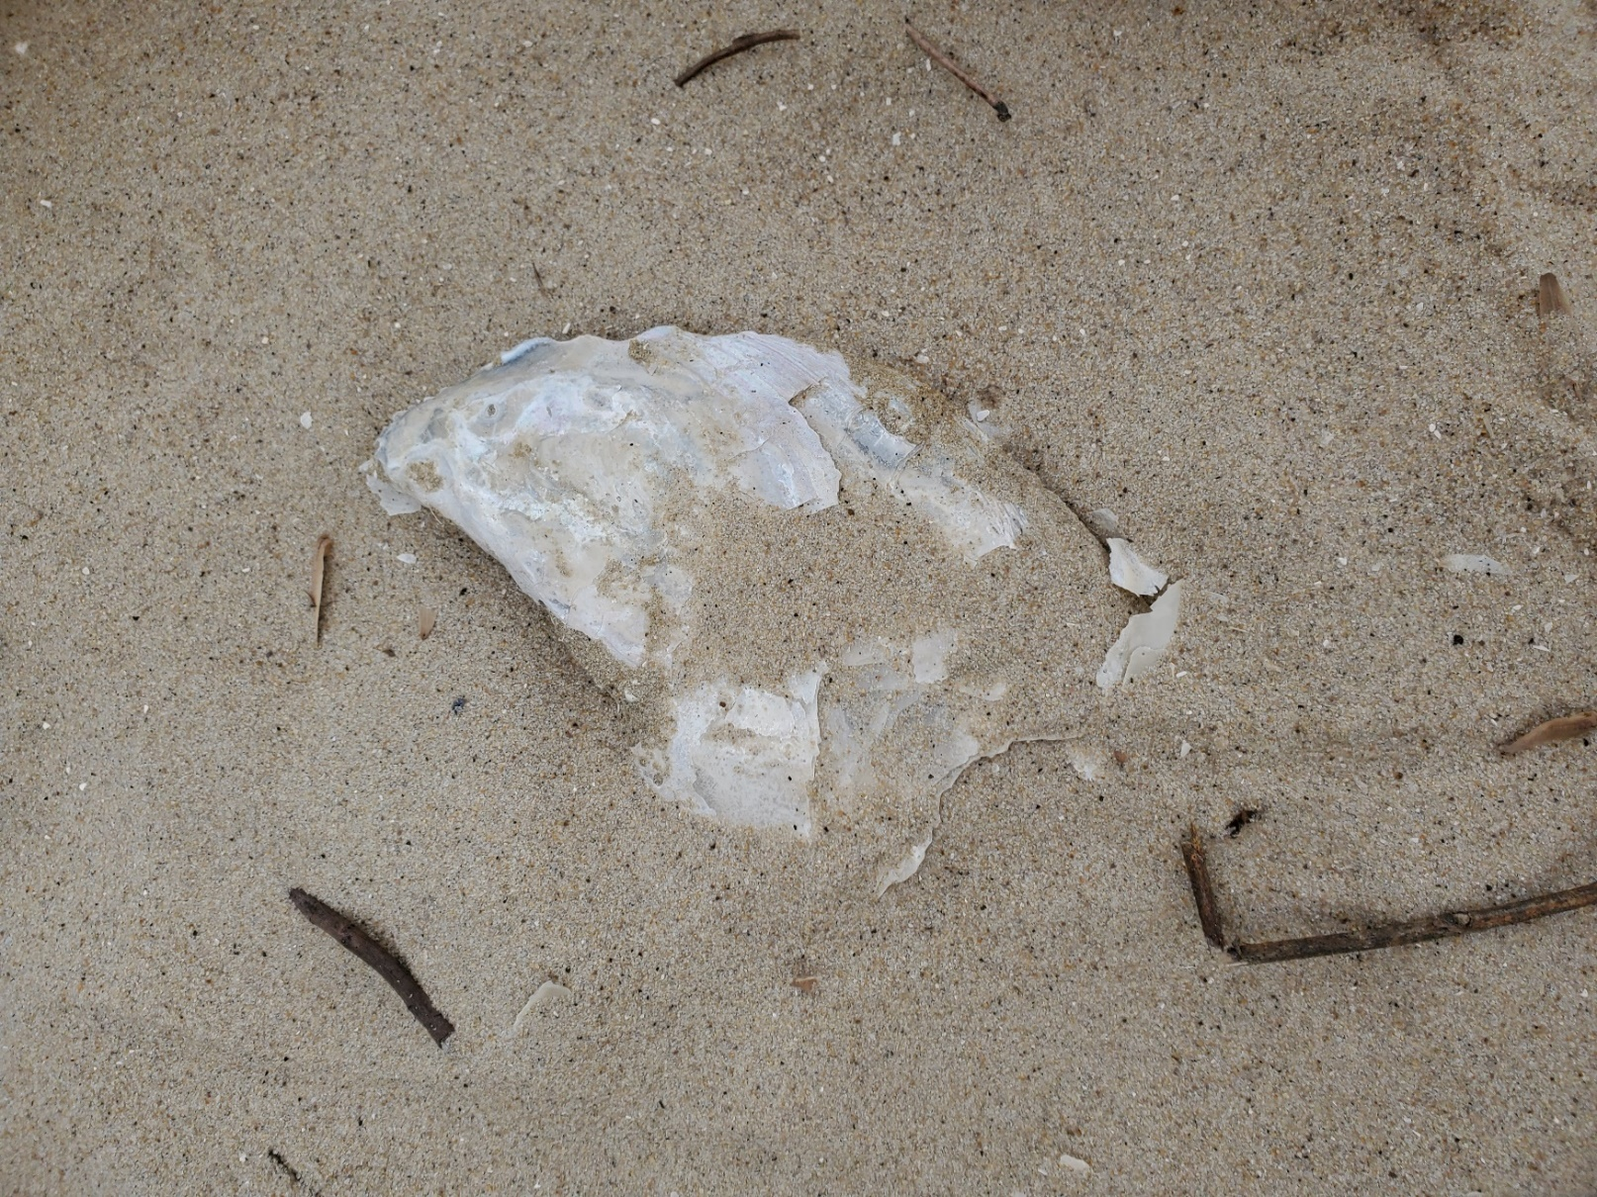
A lot of the times shells are broken, but some are mostly in one piece.
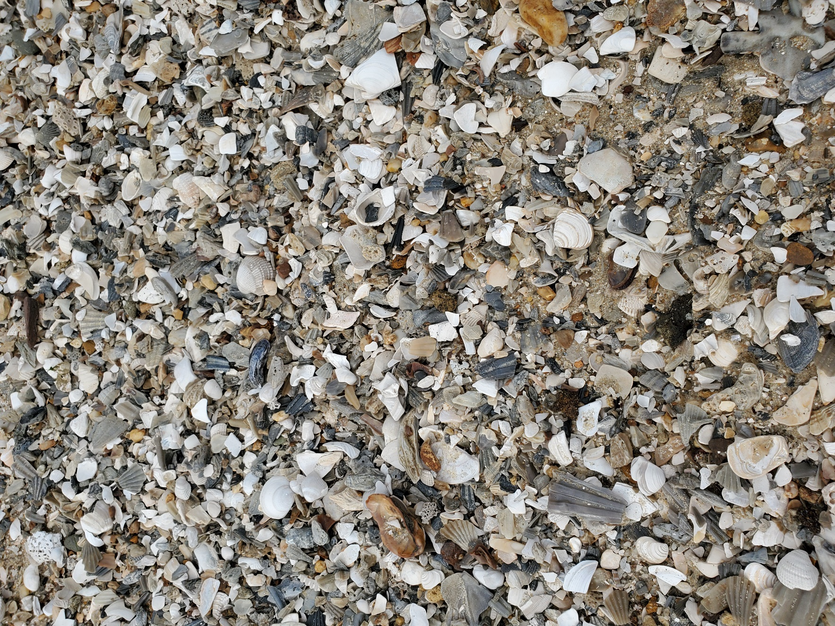
When the tide brings in big piles of shells and treasures I can sort through it to find cool stuff.

