Elaboration Phase
Extremophiles of Grand Prismatic Hot Spring – Living Colors
MS-LS2-4. Construct an argument supported by empirical evidence that changes to physical or biological components of an ecosystem affect populations.

Purpose. Students are tasked with drawing conclusions to explain that while each species of microorganisms has its own optimal temperature and pH range, multiple species can thrive in the same hydrothermal feature.

Activity Overview. The activity begins with a phenomenon -- students observe a photo of Yellowstone’s colorful Grand Prismatic Hot Spring (see Figure 1_Grand Prismatic Hot Spring). Using experiences from the lesson’s prior activities, students address two questions about the phenomenon (StudentElaborationHandout1_Think-Pair-Share). Then, students color a picture of the Grand Prismatic Hot Spring based on the spring’s water temperature bands (StudentElaborationHandout2- GrandPrismaticColoringPage). Students conclude the activity by writing a brief research report to Dr. Burnap to explain why his team of researchers should visit the Grand Prismatic in their quest of collecting data on different species of cyanobacteria.

Teacher Background Information on the Photo of Grand Prismatic Hot Spring. Grand Prismatic Hot Spring is the most photographed hydrothermal feature in Yellowstone National Park due to it striking coloration. Deeper than a 10-story building, very hot water travels 121 feet up from a crack in the Earth to reach the surface which pours into the largest hot spring in the United States and the third largest spring in the world; larger than a professional football field. From fissures in the center of this stunning hot spring, water emerges from underground at temperatures up to 198°F (92°C) – too hot to sustain most life. At this temperature, the mineral-rich water produces a breathtaking deep-blue color due to the scattering of blue wavelengths (the same reason oceans and lakes appear blue to the naked eye). Then, as the water spreads across this massive 370 ft diameter spring, it begins to cool and create concentric circles of varying temperatures. Color bands begin to appear within these temperature bands. Colors are produced by a different species of algae that thrive within a particular temperature range. These colors are caused by heat-loving algae (cyanobacteria) that contain colorful pigments. The vivid colors found in the Grand Prismatic Hot Spring are the result of microbial mats of blues, yellows, oranges, reds, and browns.
The pH of the Grand Prismatic Spring varies only slightly, ranging between 7.0 and 8.3.

Materials for Student.
Student Handouts StudentElaborationHandout1-LivingColors_Think-Pair-SharePrompts StudentElaborationHandout2-LivingColors_GrandPrismaticColoringPage StudentElaborationHandout3-GrandPrismatic_DataTable
Colored pencils

Activity Set Up and Classroom Management.
- After viewing the image of the Grand Prismatic Hot Spring, students are asked to Think-Pair-Share responses to two prompts (StudentElaborationHandout1). We have students personally reflect on, and write down responses to the two prompts (~3 minutes); then have students turn to the person next to them to share responses (~ 3 minutes). Finally, we have two groups of two come together to continue sharing (~3 minutes).

Provide each student with colored pencils and the outline image of Grand Prismatic Hot Spring (StudentElaborationHandout2- GrandPrismatic_ColoringPage). This picture has been modified from the Yellowstone National Park Junior Ranger magazine.
Also provide students with the data table identifying the thermophiles that live in each colored band (StudentElaborationHandout2-GrandPrismatic_SummaryReport). Students are tasked with coloring the image of Grand prismatic with colors that represent to temperatures that correspond to specific cyanobacteria. Students conclude the Elaboration Phase by writing a report that explains how multiple species of thermophiles can thrive in what appears to be the same environment (hint, while the minerals in the water and the pH of the water are the same throughout, the temperature of the water cools as it moves away from the center of the spring. Different cyanobacteria thrive in different temperatures).

Writing Prompts and Potential Responses for Student Research Report. Most middle-level students struggle to write evidence-based responses. To help facilitate their writing, encourage students to review data collected throughout the Some Like it Hot lesson, and incorporate the identified key words in their responses.
Key Words: biological components, color bands, cyanobacteria, ecosystem, Grand Prismatic Hot Spring, physical components, optimal temperatures, pH, thermophiles, water, etc.

Think-Pair-Share Prompts and Potential Responses

- Explain how/why multiple species of thermophiles can thrive in the same hot spring - Grand Prismatic Hot Spring – when each thermophile thrives in different environmental conditions.
Guide to Correct Response… Different species of thermophiles live in Grand Prismatic Hot Spring, but each species lives in a different temperature band. Thermophiles, like other organisms, thrive in environments with very specific biological and physical components. Two physical components of an ecosystem that we have worked with during this lesson are pH and temperature. While the Grand Prismatic has a fairly consistent pH, the water temperature varies a lot. The water that comes out of the fissure is so hot that no thermophile can live in it, but as the water moves away from the fissure it begins to cool. As it cools we begin to see evidence of different thermophilic life in temperature band.

- Explain why the thermophiles don’t “mix” or “blend” if they can all live in the same hot spring.
Guide to Correct Response…Each species of thermophiles has its own temperature and pH range. While the pH of the Grand Prismatic Hot Spring is about the same throughout, as the water spreads across this massive hot spring, it begins to cool. Each thermophile has a particular temperature range that it best thrives in, which means that thermophiles seldom “mix” or “blend” with one another.

Research Report to Dr. Burnap and Potential Responses

  - Provide an evidence-based explanation as to why the Grand Prismatic Hot Spring is so colorful.
Guide to Correct Response… Grand Prismatic Hot Spring is colorful because of the thermophiles that live there. Thermophiles are microbes which are very small, too small to see with the naked eye. But when they clump together they form mats of color. Different species of thermophiles have their own optimal temperature range, and so will live in the part of the hot spring that supports this basic need. Each thermophile produces its own pigment and therefore produces their own color. Grand Prismatic Hot Spring is so colorful because specific thermophiles, that contain specific pigments live in specific temperature bands. Thus, each water temperature band results in a different band of color.

  - Dr. Burnap wants to learn about the mechanisms that different species of cyanobacteria use to obtain life sustaining energy. If he only has time to visit one hot spring, would you recommend that he visit the Grand Prismatic Hot Spring? Provide evidence to support your claim.
Guide to Correct Response… YES … Because due to the water gradient of the Grand Prismatic Hot Spring, multiple species of Cyanobacteria thrive. The color of the organism matts and the temperature of the water could be used to identify the species of Cyanobacteria.

Table 1. Grand Prismatic Data Table
Review
For Peer
Color of Band | Temp (°F -°C) | Cyanobacteria | Information
Deep Blue | 170°F and above 87°C and above | Too hot for most bacterial growth
Yellow-Green | 147 - 162°F  63 - 72 °C | Synechococcus | Synechococcus bacteria is a yellow-green oxygenic photosynthesizer. These particular cyanobacteria prefer the upper range of photosynthetic temperatures.
Orange | 113 - 140°F  45 - 60°C | Phormidium | Phormidium is a cyanobacterium rich in orange pigments that prefers the middle temperature range (45-60°C). They produce long streamers in rusty brown mats and live closely with Chloroflexus and other bacteria to establish a microbial ecosystem. They abundantly produce carotenoids.
Brownish-Black or  Dark Burgundy | 86 - 110°F  30 - 43°C | Calothrix | Calothrix prefers the lower temperature ranges (no lower than 30°C) and is a brownish-black color. Calothrix is unique because it creates a natural “sunscreen” that allows it to survive out of the water where it is exposed to high levels of UV radiation. Water offers natural UV protection to other cyanobacteria.
Green | 95 - 158 °F  35 - 70°C | Chloroflexus | Chloroflexus is a photosynthetic bacterium that when grown in sunlight, and in the absence of oxygen, is dark green in color. This group is a facultative phototroph the uses photosynthesis under anaerobic conditions or can live heterotrophically under aerobic conditions.

StudentElaborationHandout1-LivingColors_Think-Pair-Share

Think-Pair-Share Prompts

- Explain how multiple species of thermophiles can thrive in the same hot spring - Grand Prismatic Hot Spring – when each thermophile thrives in different environmental conditions.

- Explain why the thermophiles don’t “mix” or “blend” if they can all live in the same hot spring.

StudentElaborationHandout1-LivingColors_GrandPrismaticColoringImage

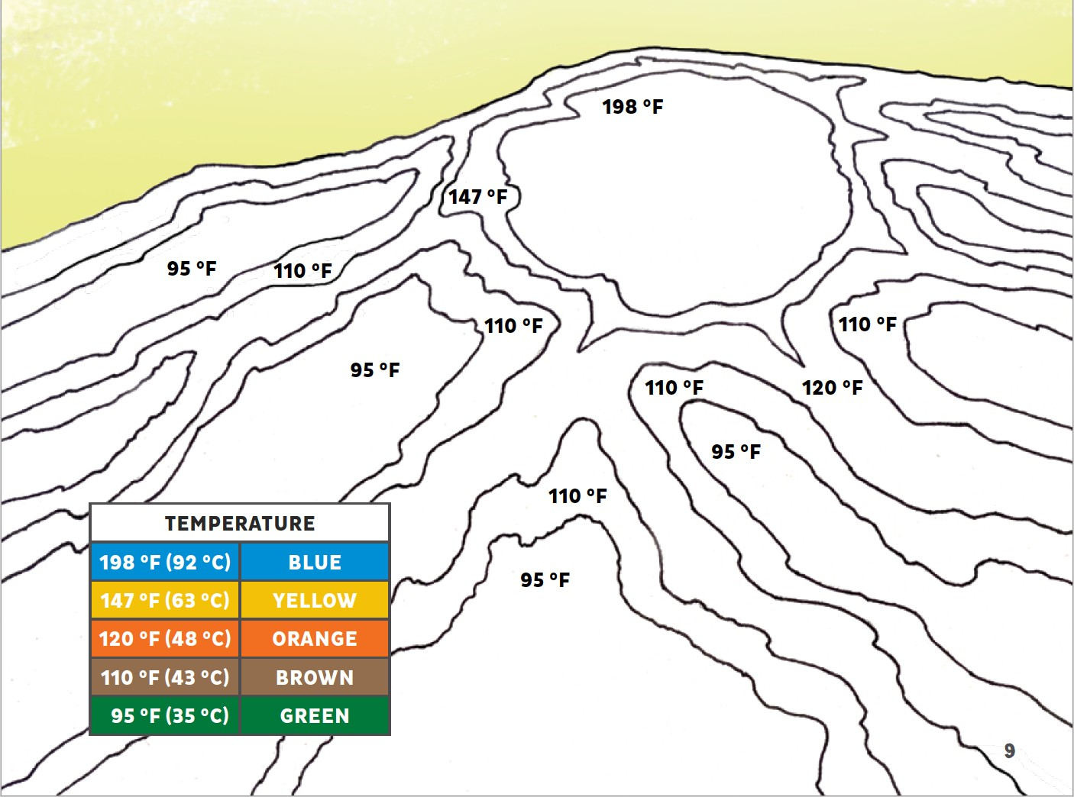

pH: 7.0 – 8.3
For
Peer
Review

pH: 7.0 – 8.3

pH: 7.0 – 8.3
pH: 7.0 – 8.3

pH: 7.0 – 8.3

StudentElaborationHandout2-LivingColors_GrandPrismaticSummaryReport

Student Name Date

Directions. Throughout this lesson you have learned about thermophiles while collecting data for Dr. Burnap and his team of microbiologists. Now, using your colored drawing of Grand Prismatic Hot Spring, the information on the data table below, and knowledge gained from earlier activities, you are tasked to write a research report for the Burnap research team. Your research report will address three writing prompts (see research report below). To help guide your written report, you are encouraged to use the following Key words in your responses: color bands, cyanobacteria, ecosystem, Grand Prismatic Hot Spring, optimal temperatures, pH, physical components, thermophiles, water, etc.

Table 1. Grand Prismatic Data Table
Color of Band | Temp (°F -°C) | Cyanobacteria | Information
Deep Blue | 170°F and above 87°C and above | Too hot for most bacterial growth
Yellow- Green | 147 - 162°F  63 - 72°C | Synechococcus  bacteria | Synechococcus bacteria are yellow-green oxygenic photosynthesizers. These particular cyanobacteria prefer the upper range of photosynthetic temperatures.
Orange | 113 - 140°F  45 - 60°C | Phormidium | Phormidium is an orange cyanobacterium that prefers the middle temperature range (45-60°C). They produce long streamers in rusty brown mats and live closely with Chloroflexus and other bacteria to establish a microbial ecosystem. They mainly produce carotenoids.
Brownish- Black or Dark Burgundy | 86 - 110°F  30 - 43°C | Calothrix | Calothrix prefers the lower temperature ranges (no lower than 30°C) and is a brownish-black  color. Calothrix is unique because it creates a natural “sunscreen” that allows it to survive out of the water where it is exposed to high levels of UV radiation. Water offers natural UV protection to other cyanobacteria.
Green | 95 - 158°F  35 - 70°C | Chloroflexus | Chloroflexus is a photosynthetic bacterium that when grown in sunlight, and in the absence of oxygen, is dark green in color. This group is a facultative phototroph the uses photosynthesis under anaerobic conditions or can live heterotrophically under aerobic conditions.

StudentElaborationHandout2-LivingColors_GrandPrismaticSummaryReport

Summary Report to Dr. Rob Burnap

  - Provide an evidence-based explanation as to why the Grand Prismatic Hot Spring is so colorful.

  - Dr. Rob Burnap wants to learn about the mechanisms that different species of Cyanobacteria use to obtain life sustaining energy. If he only has time to visit one hot spring, would you recommend that he visit the Grand Prismatic Hot Spring? Provide evidence to support your claim.

For
Peer

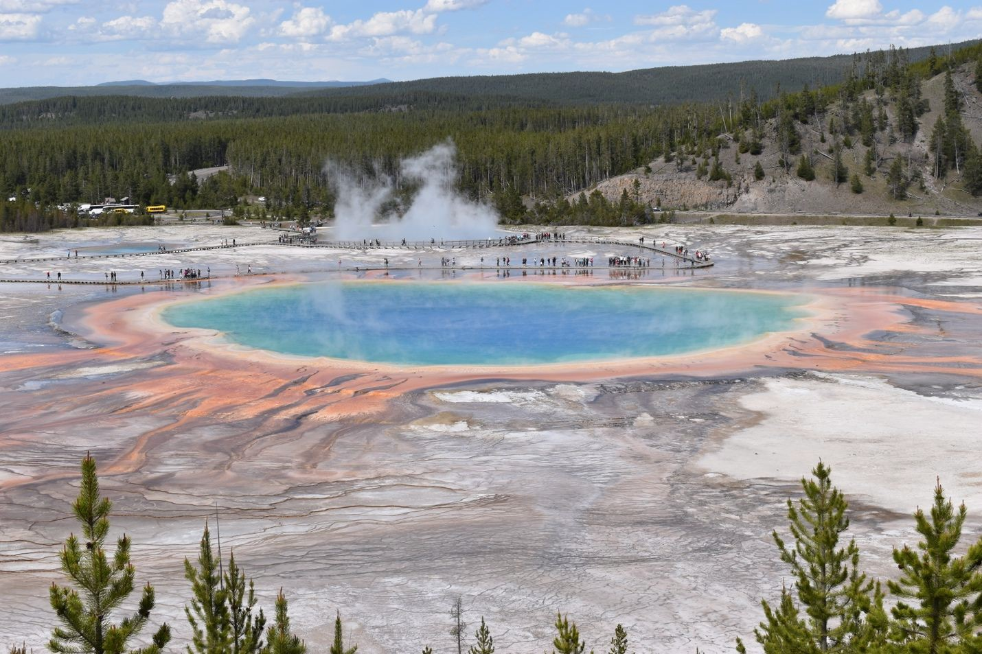
Figure 1. Yellowstone’s Grand Prismatic Hot Spring

Summative Assessment Written Reflection Instructions

MS-LS2-4. Construct an argument supported by empirical evidence that changes to physical or biological components of an ecosystem affect populations.

Purpose: During the Some Like it Hot lesson, students identified the temperature and pH of six different water samples that were designed to simulate some of Yellowstone’s hot springs. They used their data to make connections to the scientific concept that different thermophiles require different physical environmental conditions to survive. Then, students learned that the physical components of an ecosystem determine which thermophiles can thrive in that environment. Finally, students explained how multiple species of thermophiles can coexist in the same hot spring. The purpose of the Evaluation Phase is for students to demonstrate their culminating knowledge of the effects that changes to an ecosystem’s physical components can have on the populations that live in it. The writing prompts for the Evaluation Phase addresses all three NGSS dimensions for MS- LS2-4.
    - Science and Engineering Practices (SEP). “Engaging in Argument from Evidence”. The writing prompts asks students to write an oral argument that supports their claim.
    - Disciplinary Core Idea (DCI). “LS2.C: Ecosystem Dynamics, Functioning, and Resilience Ecosystems are dynamic in nature; their characteristics can vary over time. Disruptions to any physical or biological component of an ecosystem can lead to shifts in all its populations”. Students demonstrate their knowledge of how changes to the physical component of an ecosystem can lead to shifts in its population. Or by moving a organism into a new ecosystem with different physical components can lead to the death of the organism.
    - Cross Cutting Concept (CCC). “Stability and Change”. Students are asked to provide evidence of the effects of putting a thermophile that thrives in a hot spring with a low pH into a hot spring with an almost neutral pH. This is an excellent example of addressing the concept of stability and change.

Materials:
Materials for student:
Student Handout: StudentEvaluationHandout1-ReflectiveWritingPrompt

Set Up:
Distribute the StudentEvaluationHandout1-ReflectiveWritingPrompt. Allow students to utilize all resources from the Some Like it Hot activities to assist them in addressing the writing prompt (e.g., Thermometer activity, Thermophile Lab Reference Page, Thermophile Lab Data, Hydrothermal Features handout, and Grand Prismatic image). Providing students

TeacherEvaluationHandout1-TeacherGuide_Reflection

with the writing prompt the day before allows them time to gather and organize the materials they may want to use as they write their responses. The next day we give our students at least 30-minutes in class to construct their response to the writing prompt.

Storyline and Student Writing Prompt:
With over 3,000 earthquakes each year, Yellowstone National Park is one of the most seismically active areas in the United States. During an earthquake, energy is released along fractures in the crust, causing the ground to shake. While most of Yellowstone’s earthquakes register under 3.0 on the moment magnitude scale (M_{w}), three months ago Yellowstone experienced an earthquake that registered 6.7 M_{w}. This seismic event caused a new fracture (or “pipe”) to open between Norris Geyser Basin and Grand Prismatic Hot Spring. Norris Geyser Basin has some of the hottest water in Yellowstone which is now traveling into the Grand Prismatic. Since the earthquake, geologists from the Yellowstone Volcano Observatory have been monitoring this area and have determined that the Grand Prismatic Hot Spring is experiencing changes to its physical environment. While the pH of the water has changed very little, the overall water temperature has increased over 15 °F. Scientists have two lines of thought about the outcome of the thermophiles who call the Grand Prismatic “home”:
- Thermophiles can survive in warm-hot waters and since the pH of the water changed only slightly, the thermophiles that lived in the waters of Grand Prismatic will continue to thrive in the hotter water.
- Thermophiles can survive in warm-hot waters, but while the pH of the water stayed relatively the same, the increase in water temperature may cause some populations of thermophiles to die.

Writing Prompt. Use the scientific evidence collected and scientific reasoning skills developed throughout this lesson to compare and critique the two statements. Then make a written argument to support or refute each statement. In your responses, you are encouraged to use some of the key words addressed in the Some Like it Hot lesson: environment, hot springs, hydrothermal features, optimal temperature, pH, thermophiles, physical components, water, and Yellowstone National Park. Underline the key words in your response.

Rubric for Scoring Responses
Criteria | Does Not Meet Expectations | Meets Expectations | Exceeds Expectations
Construction of Argument (scientific reasoning) | States a claim or refutes a claim but fails to provide supporting evidence | States a claim or refutes a claim that is supported by scientific evidence | Clearly articulates a claim that supports or refutes the statement using multiple pieces of  scientific evidence
Examples used to support claim | Failed to provide an example or the examples used did not support the claim | Used one example to support or refute the claim | Used more than one example to support or refute the claim

Key Words | Written response used very few Key Words | Written response used most of the Key Words | Written response used all of the Key Words
Grammatical | Multiple grammatical | Only a couple | No grammatical errors;
Correctness | errors and response | grammatical errors; | response is in logical
 | does not flow in  logical order | response flows for  ease of read. | order for ease of read.

StudentEvaluationHandout1-ReflectiveWritingPrompt

Evaluation Phase Reflective Writing Prompt

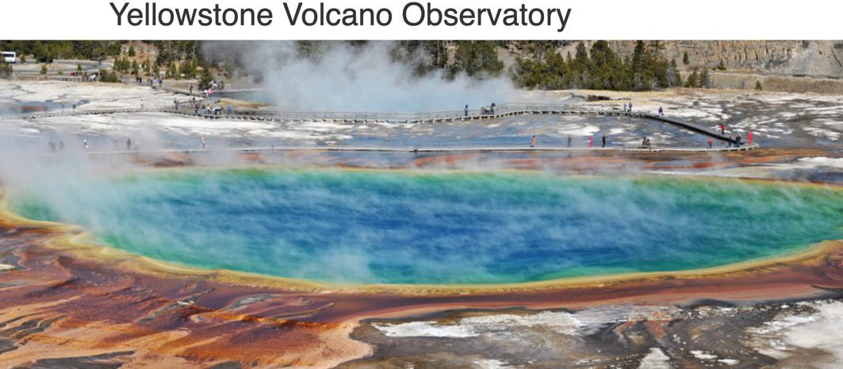
Throughout the Some Like it Hot lesson, you learned that there are organisms (thermophiles) that can thrive in aquatic environments with extremely high temperatures and very high or low pH. You also learned that Yellowstone National Park has over 10,000 hydrothermal features that serve as home to some of these unusual organisms. During the Extreme Environments Lab, you determined the temperature and pH of six different solutions, and identified a thermophile that could thrive in each of these environments with unique physical components. You identified potential geyser basin locations of thermophiles in the Search for Thermophiles activity and then, in the Living Colors activity, you explained how five different species of thermophiles could all thrive in Yellowstone’s Grand Prismatic Hot Spring; a hot spring with a temperature range of 95-198°F (30-95°C) and a pH range of 7.0 - 8.3.

Storyline. With over 3,000 earthquakes each year, Yellowstone National Park is one of the most seismically active areas in the United States. During an earthquake, energy is released along fractures in the
Review
crust, causing the ground to shake. While most of Yellowstone’s earthquakes register under
3.0 on the moment magnitude scale (M_{w}), three months ago Yellowstone experienced an earthquake that registered 6.7 M_{w}. This seismic event caused a new fracture (or “pipe”) between Norris Geyser Basin and Grand Prismatic Hot Spring. Norris Geyser Basin has some of the hottest water in Yellowstone which is now traveling into the Grand Prismatic. Since the earthquake, geologists from the Yellowstone Volcano Observatory have been monitoring this area and have determined that the Grand Prismatic Hot Spring is experiencing changes to its physical environment. While the pH of the water has changed very little, the overall water temperature has increased over 15F. Scientists have two lines of thought about the outcome of the thermophiles who call the Grand Prismatic “home”.

Writing Prompt. Use the scientific evidence collected and scientific reasoning skills developed throughout this lesson to compare and critique the two statements. Then make a written argument to support or refute each statement. In your responses, you are encouraged to use the key words addressed in the Some Like it Hot lesson: environment, hot springs, hydrothermal features, optimal temperature, pH, thermophiles, physical components, water, and Yellowstone National Park. Underline the key words in your response.

StudentEvaluationHandout1-ReflectiveWritingPrompt

Student Name -

Two Lines of Thought

- Thermophiles can survive in warm-hot waters and since the pH of the water changed only slightly, the thermophiles that live in the waters of Grand Prismatic will continue to thrive in the hotter water.
- Thermophiles can survive in warm-hot waters, but while the pH of the water stayed relatively the same, the increase in water temperature may cause some populations of thermophiles to die.

