Engagement Phase Thermometer Activity

MS-LS2-4. Construct an argument supported by empirical evidence that changes to physical or biological components of an ecosystem affect populations.

Some Like it Hot, Lesson Objective
Students will be able to construct written arguments supported by empirical evidence that changes to physical components of an ecosystem (hot spring) affect populations (thermophiles).

Purpose: The purpose of the Thermometer activity in the Engagement Phase is to introduce students to one of two abiotic factors addressed in this lesson. Students identify optimal temperature ranges of some of Yellowstone National Park’s more common animals. Students also learn that there are organisms that can live in environmental temperatures above that of the more common animals.

Overview of Activity. Students are given a brief virtual tour of Yellowstone National Park and introduced to a few of the organisms that reside in the park. As they watch the video, students are tasked with asking questions about Yellowstone’s organisms and the environmental conditions in which they live. After the video, students discuss optimal living conditions of specific organisms of Yellowstone. Then students are introduced to a group of organisms (thermophiles) that thrive in Yellowstone’s geothermal features, specifically Yellowstone’s hot springs. Students create labeled thermometers to help them identify and classify organisms that thrive in different living conditions. By the end of the Engagement Phase, students are led to the driving question, “How do changes to the physical components of an ecosystem affect populations?” This driving question guides the lesson’s remaining activities.

Materials
Materials for student
Student Handouts: StudentEngagementHandout1-GroupThermometer
StudentEngagementHandout2-OrganismCards
Lab Journal
Post-it Notes (3” x 3”)
BluTack: Poster putty for sticking Organism Cards to the class thermometer

Materials for teacher
Giant Post-it note paper (25” x 30” or larger) or for a less expensive option we might suggest using butcher paper.
Teacher Handouts: TeacherEngagementHandout2-ThermometerKEY_TeacherGuide TeacherEngagementHandout3-ExtendedThermometerKey
Lesson Videos: Video #1- https://www.youtube.com/watch?v=AKoFN9brF_Y
Video #2 - https://www.youtube.com/watch?v=t5IDzsVTf-Q
Photos of Hot Springs & Thermophiles:
- Engagement Figure 1 – Biscuit Basin – Sapphire Pool
- Engagement Figure 2 – Firehole River Hot Spring
- Engagement Figure 3 – Orange Matting
- Engagement Figure 4 – Upper Geyser Basin

Activity Set Up
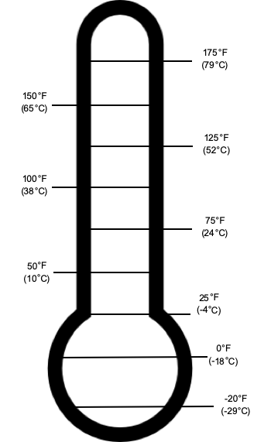
On a giant Post-it note pad (or butcher paper), draw Figure 1, which includes the outline of the thermometer and the corresponding temperature readings. Because this serves as a visual for the entire class, make this drawing as tall as the Post-it note pad (or butcher paper) allows. This will be referred to as Teacher-Thermometer 1. On a separate giant Post-it (or butcher paper), draw Figure 2, including the outline of the thermometer and corresponding temperatures. Again, make this drawing as tall as the paper allows. This will be referred to as Teacher-Thermometer 2.

Figure 1. Original thermometer image. (Teacher-Thermometer 1)
-20°F
(-29°C)
100°F
(38°C)
0°F
(-18°C)
50°F
(10°C)
25°F
(-4°C)
75°F
(24°C)
Print and cut out student Organism Cards on StudentEngagementHandout2-OrganismCards. To help keep track of each group’s cards, we found it helpful to provide each group with cards printed on different colored paper. If you laminate the cards, they can be used year after year.
Figure 2. Extended thermometer image. (Teacher-Thermometer 2)
On a third giant Post-it (or butcher paper), label it as “Driving Question Board” and hang it up at the front of the classroom next to the giant Teacher-Thermometer 1.

Introduction to Yellowstone. Play the following 3-minute National Geographic video: https://www.youtube.com/watch?v=AKoFN9brF_Y. This video provides an overview of Yellowstone National Park and introduces the organisms that will be used in the Thermometer activity. (Tip: to get students more interested in the video, we ask “Has anyone ever been to Yellowstone and actually saw one of Yellowstone’s hot springs?”. Students who have traveled to Yellowstone are always willing to share their stories. You can also share stories of accidents that have occurred in Yellowstone’s geothermal features.)

Before students begin watching the video say, “Yellowstone National Park is America’s first and oldest national park. It is located in the NW corner of Wyoming and contains over two million acres of diverse environments, some of which sits on top of a supervolcano. As you watch this video, write down at least two questions you have about Yellowstone National Park.”

When students finish watching the Yellowstone video assemble them into groups of 3-4 and ask them to share their questions with their group. Once everyone has had a chance to share, the group is charged to come up with two questions that best represent the 6-8 questions shared in their group. We have groups designate a spokesperson who will read their questions aloud to the class. After each question is read, students are provided one- minute to brainstorm a potential answer/response with their group members. Then 1-2 groups are called upon to share their feedback. Classroom rules in force that only one person speaks at a time.

As the facilitator, lead the class in a conversation using these questions: “I noticed that a lot of your questions had to do with animals in Yellowstone.” “Do you think that all organisms thrive in the same living conditions?” “What does it mean for an organism to thrive?” “Do you think that all animals like to live in the same temperature?” “How do we measure temperature?”

Thermometer Activity. Ask students to recall some of the organisms they saw in the video (organisms from video: bison, gray wolf, grizzly bear, mountain lion, river otter, and ruffed grouse). This often leads to discussions about how these organisms are similar to or different from organisms that live in students’ hometown/city. Distribute the StudentEngagementHandout1-GroupThermometer and StudentEngagementHandout2- OrganismCards (already cut) to each group. Instruct students to reflect on each organism and think about the temperature or temperature range (optimal temperature) in which each organism would thrive. To help students better understand “optimal temperature” we found it helpful to provide students with the following example: Say, “Let’s work on the card marked, “Humans” together. We know that humans can survive in very cold

temperatures (think Alaska in the winter) or very hot temperatures (think Arizona in the summer), but humans best thrive in more moderate temperatures.”

Task groups to decide on the optimal temperature for each of the five Yellowstone organisms, then write the name of each organism next to the agreed upon temperature on their group thermometer.

To engage students in a whole class discussion about their decisions, student groups transfer information from their small group thermometer to the large class thermometer by sticking their cut-out Organism-Cards (using the poster putty), on the Teacher- Thermometer 1, beside the temperature agreed upon by their group. After all groups have placed their Organism-Cards on the Teacher-Thermometer 1, there is a good chance that not all groups will place the same organisms next to the same optimal temperature. Take advantage of this teachable moment to engage students in a conversation about how different organisms have their own optimal temperature. For example, wolves have more success hunting during the winter (colder temperatures) but can survive in warmer temperatures. If discrepancies exist as to where student groups placed their organisms on the thermometer, engage them in a discussion to reach a general consensus as to where they think each organism should be placed. Explain to students that all of the animals (including humans) placed on the Teacher-Thermometer 1 are considered mesophiles.
For Peer Review
This means that these organisms function best in moderate temperatures (68-104°F; 20- 40°C). The documents, TeacherEngagementHndout2-ThermometerKEY_TeacherGuide and TeacherEngagementHandout3-ClassThermometerActivity_EntendedThermometerKey provide additional information to facilitate class discussions.

Once general agreement on optimal temperatures has been established, ask students if they think there are organisms that can live in temperatures higher than the mountain lion or the gray wolf? Say to the students, “Our thermometer only goes up to 100°F (38°C), how could we measure the optimal temperature of organisms that might thrive in temperatures above 100°F (38°C)?”

Helpful Suggestions. To introduce students to the optimal temperature ranges of thermophiles, place Teacher-Thermometer 2 (see figure 2 at the top of this document) over the top of Teacher-Thermometer 1(see figure 1 at the top of this document). Teacher- Thermometer 2 has the extended temperature range suitable for thermophiles. The TeacherEngagementHandout2-ThermometerKey document has a table with information about each of the five Yellowstone organism and the two thermophiles that will be introduced in this activity. The TeacherEngagementHandout3-ExtendedThermometerKey document contains pictures of each Yellowstone organism next to the correct optimal

temperature. We suggest printing out pictures of the organisms and placing them on your thermometer to provide students with a visual image of each Yellowstone organism.

Continue the class conversation by explaining how there is another group of organisms found in Yellowstone National Park, called extremophiles (microorganisms that thrive in physically or geochemically extreme conditions, which can be very hot or very cold, very acidic or very alkaline). If these extremophiles thrive in temperatures between 35°-90°C, they are identified as thermophiles. In addition to their preference for extremely hot living conditions, some of these thermophilic microorganisms can also thrive in highly acidic or highly basic environments. It may be helpful to break down the term “thermophile” for students to better understand the word. Thermo- refers to heat and - phile means loving, so the word “thermophile” refers to heat loving organisms.

Introduce the two thermophiles listed at the bottom of table in TeacherEngagementHandout2-ThermometerKey: Oscillatoria and Hydrogenobaculum. Have students predict where they think these thermophilic organisms might be found on the thermometer, using the word thermophile as a hint. We found it helpful to print out pictures of the two microorganisms and allow students to look at the pictures and discuss similarities and difference between these organisms.

Establishing the Driving Question. The second Yellowstone video and the follow-up pictures, serve to initiate student questions and ultimately identify the lesson’s Driving Question. Play the Smithsonian Channel video for your students as a way to introduce them to the hot springs of Yellowstone National Park: https://www.youtube.com/watch?v=t5IDzsVTf-Q. Follow the video with four photos of some of Yellowstone’s hot springs and thermophiles (Engagement Phase Figures 1-4). The photos reinforce what students saw in the video, in terms of the diverse thermophiles that thrive in very diverse hot springs.

As students prepare to watch the second video and observe the photos, ask them to write down at least two questions, in their lab journal, that come to mind about the geothermal features in Yellowstone. This should be done individually and silently while the video plays and/or while they view the photos. When students finish watching the Yellowstone video and observing the photos, ask them to share their questions with their group. Then charge each group to come up with two questions that best represent the 6-8 questions shared in their group. Each of the two questions is written on the 3” x 3” Post-it Notes (one question per Post-it). After groups have written their questions, they will read their questions to the class as they add their questions to the Driving Question Board. Once all groups have posted their questions, guide the discussion toward thinking about what kind of organisms might survive in a hot spring. Ask students: “What types of living conditions are present in

these hot springs?” “What do you think causes the colored bands we saw in some of Yellowstone’s hot springs?” The end goal of these questions is to steer students toward the driving question for the lesson: “Do changes to the physical components (e.g. water temperature or pH) of an ecosystem affect populations? Why or why not?”

TeacherEngagementHandout2-ClassThermometerActivity_ExtendedThermometerKey

Engagement Phase Extended Thermometer Key

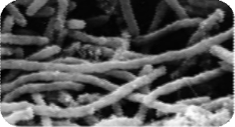

150°F (65°C)
175°F (79°C)
Hydrogenobaculum

Oscillator

Mountain Lion

100°F (38°C)

Human
125°F (52°C)

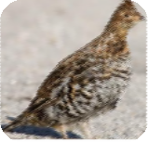
Ruffed Grouse

Bison
75°F (24°C)

Gray Wolf
50°F (10°C)

25°F (-4°C)

River Otter

0°F
(-18°C)

-20°F (-29°C)

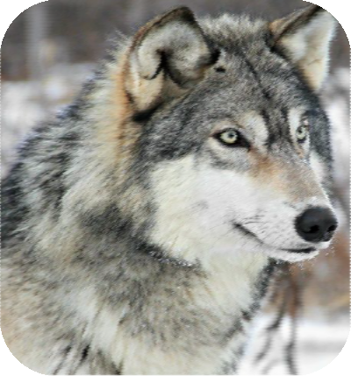
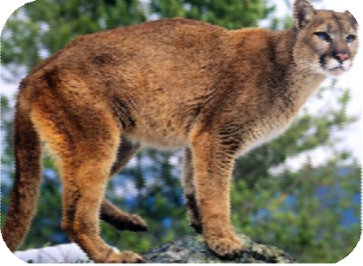
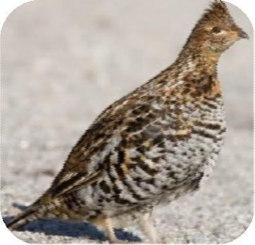
TeacherEngagementHandout2-ClassThermometerActivity_ExtendedThermometerKey

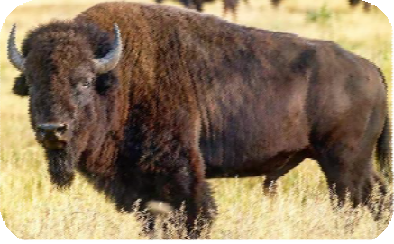

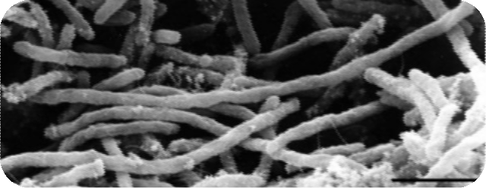

For
Peer

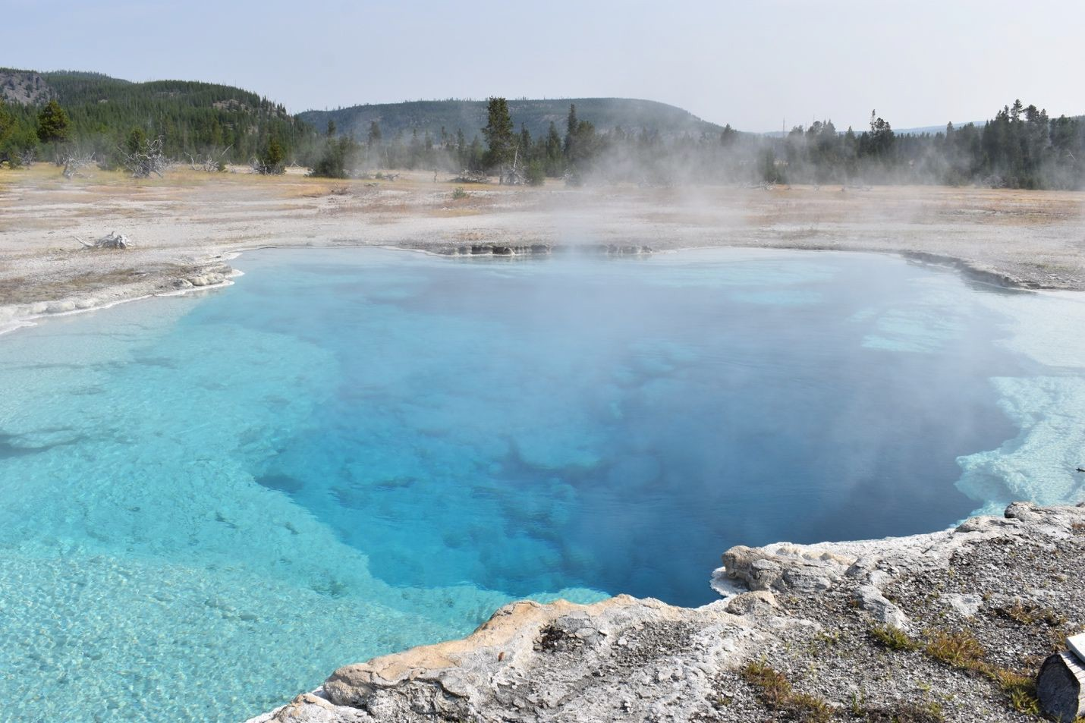
Figure 1. The superheated water of the deep Sapphire Pool located in Biscuit Basin.

For
Peer

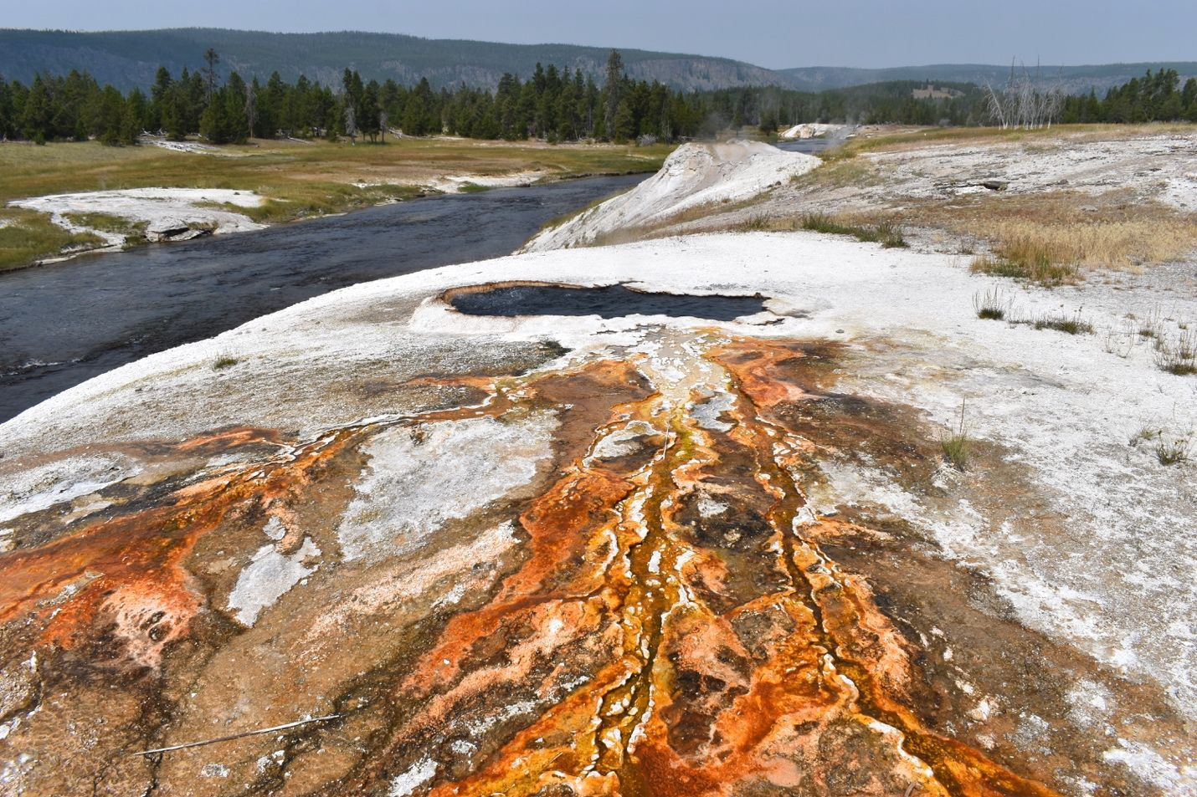
Figure 2. This image shows hot springs along the Firehole river in Yellowstone’s lower loop.

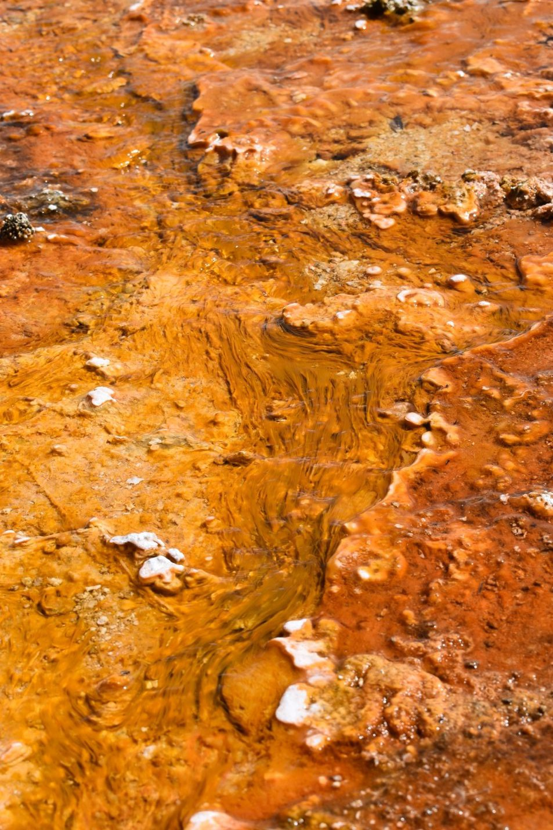
For
Peer

Figure 3. the vivid orange color and matting is evidence of thermophiles. microbes can grow to astronomical numbers and clump together to form large, easily visible ‘mats’ of various colors, depending upon the pigmentation of the particular microbial species dominating the population of the mat. They are able to form mats because some microbes produce a slimy glue-like material that keeps the cells together

For
Peer

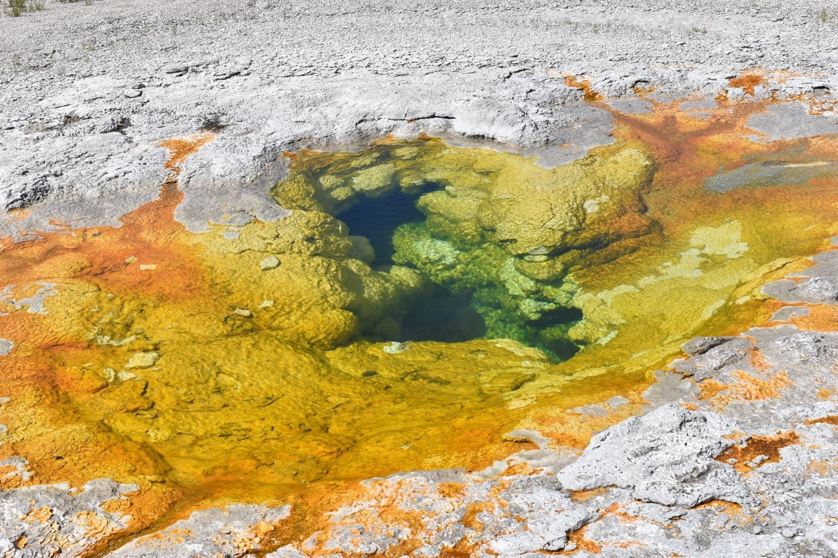
Figure 4. A colorful display of color signifies the presence of various thermophiles.

Background Information about Thermophiles
Yellowstone’s microorganisms come from all three domains of life: Archaea, Bacteria, and Eukarya. Archaea are single-celled prokaryotic organisms whose cells lack a nuclei and membrane-bound organelles. Their semi-rigid cell wall protects them from some of the harshest environments on Earth. They can live in low pH environments and in temperatures reaching almost 100C. Similar to archaea, bacteria are single-celled prokaryotic organisms but prefer environments with slightly cooler temperatures, around 85C and a more neutral pH, although these bacteria may be found in all pH ranges.
Bacteria that are phototrophic derive their energy from photosynthesis. Chemotrophic bacteria obtain their energy by breaking down chemical compounds through oxidation reactions of chemical compounds, instead of sunlight. Eukaryotes are single-cellular or multi-cellular organisms such as protists (algae), fungi, plants, and animals. Eukaryotes are made up of one or more eukaryotic cells; cells that contain a membrane-bound nuclei and organelles, and enclosed by a plasma membrane. Most eukaryotic algae are single-celled but can form long colonies or strands. Algae are neither plant, animal or fungi and are believed to have evolved from cyanobacteria, also known as blue-green algae from the bacteria domain. Algae are mostly photosynthetic but lack true roots, stems and leaves.
Their optimal pH range is between 8.2 and 8.7 and optimum growth temperatures range between 20 - 30C, which is much cooler than either archaea and bacteria.

Due to Yellowstone’s extreme environmental conditions, life at the microlevel flourishes. In the 1960s, Thomas Brock discovered Thermus aquaticus from a hot spring in Yellowstone. Thermus aquaticus would later become useful because it contains enzymes that can function at the very high temperatures found in the hot springs. One of these enzymes isolated from Thermus aquaticus was a DNA replication enzyme that makes PCR practical because it could withstand the heat of the PCR process without breaking down like ordinary polymerase enzymes. This led Science Magazine to name Taq polymerase the first “Molecule of the Year” in 1989. In 2016, researchers at the Department of Energy’s Oak Ridge National Laboratory isolated Nanopusillus acidilobi, a thermoacidophile from domain Archaea, which developed a unique way to acquire biosynthetic molecules from host cells through cell-to-cell contact (Science News, 2016). An even more recent discovery came from a group of researchers from Montana State University who hiked more than 10 miles into the backcountry of Yellowstone to discover a community of microorganisms living in a sapphire-blue hot spring located over 8,000 feet above sea level on the Continental Divide. This pool of volcanic gases was a mix of snowmelt and rainwater and contained more microbial biodiversity in a thumbnail-sized sample than all of the animal and plant diversity in Yellowstone (Science News, 2019).

StudentEngagementHandout1-GroupThermometer

Group Thermometer
Below is a thermometer that displays a temperature range from -20F (-29C) to 100 F (38C). Discuss with your group, where each of the five Yellowstone animals (bison, gray wolf, mountain lion, river otter, and ruffed grouse) and a human should be placed on the thermometer to best represent each animal’s optimal temperature. On your group’s thermometer, write the name of each animal next to the temperature that best represent the animal’s optimal growth temperature. Then write your group name on the back of each Organism-Card. You will be asked stick your Organism-Cards on the teacher’s large class thermometer. Be prepared to defend the placement of your organisms.

100°F (38°C)

75°F (24°C)

50°F (10°C)

25°F (-4°C)

0°F
(-18°C)

-20°F (-29°C)

For
Peer Review

StudentEngagementHandout2-OrganismCards

HUMAN | RIVER OTTER
RUFFED GROUSE | GRAY WOLF
MOUNTAIN LION | BISON

