Summative Assessment Written Reflection Instructions

MS-LS2-4. Construct an argument supported by empirical evidence that changes to physical or biological components of an ecosystem affect populations.

Purpose: During the Some Like it Hot lesson, students identified the temperature and pH of six different water samples that were designed to simulate some of Yellowstone’s hot springs. They used their data to make connections to the scientific concept that different thermophiles require different physical environmental conditions to survive. Then, students learned that the physical components of an ecosystem determine which thermophiles can thrive in that environment. Finally, students explained how multiple species of thermophiles can coexist in the same hot spring. The purpose of the Evaluation Phase is for students to demonstrate their culminating knowledge of the effects that changes to an ecosystem’s physical components can have on the populations that live in it. The writing prompts for the Evaluation Phase addresses all three NGSS dimensions for MS- LS2-4.
    - Science and Engineering Practices (SEP). “Engaging in Argument from Evidence”. The writing prompts asks students to write an oral argument that supports their claim.
    - Disciplinary Core Idea (DCI). “LS2.C: Ecosystem Dynamics, Functioning, and Resilience Ecosystems are dynamic in nature; their characteristics can vary over time. Disruptions to any physical or biological component of an ecosystem can lead to shifts in all its populations”. Students demonstrate their knowledge of how changes to the physical component of an ecosystem can lead to shifts in its population. Or by moving a organism into a new ecosystem with different physical components can lead to the death of the organism.
    - Cross Cutting Concept (CCC). “Stability and Change”. Students are asked to provide evidence of the effects of putting a thermophile that thrives in a hot spring with a low pH into a hot spring with an almost neutral pH. This is an excellent example of addressing the concept of stability and change.

Materials:
Materials for student:
Student Handout: StudentEvaluationHandout1-ReflectiveWritingPrompt

Set Up:
Distribute the StudentEvaluationHandout1-ReflectiveWritingPrompt. Allow students to utilize all resources from the Some Like it Hot activities to assist them in addressing the writing prompt (e.g., Thermometer activity, Thermophile Lab Reference Page, Thermophile Lab Data, Hydrothermal Features handout, and Grand Prismatic image). Providing students

TeacherEvaluationHandout1-TeacherGuide_Reflection

with the writing prompt the day before allows them time to gather and organize the materials they may want to use as they write their responses. The next day we give our students at least 30-minutes in class to construct their response to the writing prompt.

Storyline and Student Writing Prompt:
With over 3,000 earthquakes each year, Yellowstone National Park is one of the most seismically active areas in the United States. During an earthquake, energy is released along fractures in the crust, causing the ground to shake. While most of Yellowstone’s earthquakes register under 3.0 on the moment magnitude scale (M_{w}), three months ago Yellowstone experienced an earthquake that registered 6.7 M_{w}. This seismic event caused a new fracture (or “pipe”) to open between Norris Geyser Basin and Grand Prismatic Hot Spring. Norris Geyser Basin has some of the hottest water in Yellowstone which is now traveling into the Grand Prismatic. Since the earthquake, geologists from the Yellowstone Volcano Observatory have been monitoring this area and have determined that the Grand Prismatic Hot Spring is experiencing changes to its physical environment. While the pH of the water has changed very little, the overall water temperature has increased over 15 °F. Scientists have two lines of thought about the outcome of the thermophiles who call the Grand Prismatic “home”:
- Thermophiles can survive in warm-hot waters and since the pH of the water changed only slightly, the thermophiles that lived in the waters of Grand Prismatic will continue to thrive in the hotter water.
- Thermophiles can survive in warm-hot waters, but while the pH of the water stayed relatively the same, the increase in water temperature may cause some populations of thermophiles to die.

Writing Prompt. Use the scientific evidence collected and scientific reasoning skills developed throughout this lesson to compare and critique the two statements. Then make a written argument to support or refute each statement. In your responses, you are encouraged to use some of the key words addressed in the Some Like it Hot lesson: environment, hot springs, hydrothermal features, optimal temperature, pH, thermophiles, physical components, water, and Yellowstone National Park. Underline the key words in your response.

Rubric for Scoring Responses
Criteria | Does Not Meet Expectations | Meets Expectations | Exceeds Expectations
Construction of Argument (scientific reasoning) | States a claim or refutes a claim but fails to provide supporting evidence | States a claim or refutes a claim that is supported by scientific evidence | Clearly articulates a claim that supports or refutes the statement using multiple pieces of  scientific evidence
Examples used to support claim | Failed to provide an example or the examples used did not support the claim | Used one example to support or refute the claim | Used more than one example to support or refute the claim

Key Words | Written response used very few Key Words | Written response used most of the Key Words | Written response used all of the Key Words
Grammatical | Multiple grammatical | Only a couple | No grammatical errors;
Correctness | errors and response | grammatical errors; | response is in logical
 | does not flow in  logical order | response flows for  ease of read. | order for ease of read.

StudentEvaluationHandout1-ReflectiveWritingPrompt

Evaluation Phase Reflective Writing Prompt

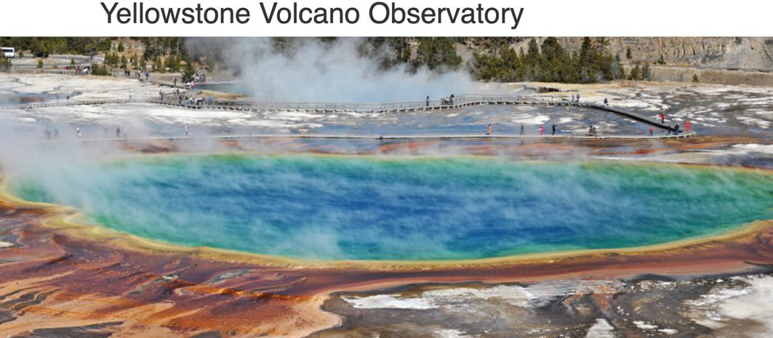
Throughout the Some Like it Hot lesson, you learned that there are organisms (thermophiles) that can thrive in aquatic environments with extremely high temperatures and very high or low pH. You also learned that Yellowstone National Park has over 10,000 hydrothermal features that serve as home to some of these unusual organisms. During the Extreme Environments Lab, you determined the temperature and pH of six different solutions, and identified a thermophile that could thrive in each of these environments with unique physical components. You identified potential geyser basin locations of thermophiles in the Search for Thermophiles activity and then, in the Living Colors activity, you explained how five different species of thermophiles could all thrive in Yellowstone’s Grand Prismatic Hot Spring; a hot spring with a temperature range of 95-198°F (30-95°C) and a pH range of 7.0 - 8.3.

Storyline. With over 3,000 earthquakes each year, Yellowstone National Park is one of the most seismically active areas in the United States. During an earthquake, energy is released along fractures in the
Review
crust, causing the ground to shake. While most of Yellowstone’s earthquakes register under
3.0 on the moment magnitude scale (M_{w}), three months ago Yellowstone experienced an earthquake that registered 6.7 M_{w}. This seismic event caused a new fracture (or “pipe”) between Norris Geyser Basin and Grand Prismatic Hot Spring. Norris Geyser Basin has some of the hottest water in Yellowstone which is now traveling into the Grand Prismatic. Since the earthquake, geologists from the Yellowstone Volcano Observatory have been monitoring this area and have determined that the Grand Prismatic Hot Spring is experiencing changes to its physical environment. While the pH of the water has changed very little, the overall water temperature has increased over 15F. Scientists have two lines of thought about the outcome of the thermophiles who call the Grand Prismatic “home”.

Writing Prompt. Use the scientific evidence collected and scientific reasoning skills developed throughout this lesson to compare and critique the two statements. Then make a written argument to support or refute each statement. In your responses, you are encouraged to use the key words addressed in the Some Like it Hot lesson: environment, hot springs, hydrothermal features, optimal temperature, pH, thermophiles, physical components, water, and Yellowstone National Park. Underline the key words in your response.

StudentEvaluationHandout1-ReflectiveWritingPrompt

Student Name -

Two Lines of Thought

- Thermophiles can survive in warm-hot waters and since the pH of the water changed only slightly, the thermophiles that live in the waters of Grand Prismatic will continue to thrive in the hotter water.
- Thermophiles can survive in warm-hot waters, but while the pH of the water stayed relatively the same, the increase in water temperature may cause some populations of thermophiles to die.

