Name: __________________________________ Date: ______________

Directions: In your group, read about each case study of species of Lemur and complete the chart below. You will become an expert on the species and teach the other members of your group.

Introduction: Habitat destruction will force most of Madagascar’s wild lemurs to shift their ranges over the next 70 years, a new study suggests. The vulnerable primates are under pressure from deforestation and subsistence hunting. In 1987, World Wildlife International declared that the lemurs are the most gravely endangered group of primates in the world. Is there hope for this highly threatened species?
Lemur Species
- Ring-Tailed Lemur
- Silky Sifaka Lemur
- Bamboo Lemurs
- Aye-Aye

Species of Lemur | Description of Habitat | Food Source | Threats to habitat / Connections to other species

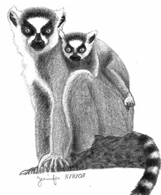
Case Study #1 Ring-Tailed Lemur
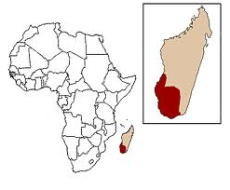
Scientific Name: Lemur catta

Kingdom: Animalia
Phylum: Chordata
Class: Mammalia
Order: Primates
Family: Lemuridae
Genus Species: Lemur (ghost, specter) catta (cat)

Species Description: A small endangered primate with a black and white banded tail. Males have a fingernail-like spur near each wrist that emits a strong scent for marking territories. Tail length of the male is 599 mm (23.6 in).

Habitat: Endemic to southern/southwestern Madagascar, the ring-tailed lemur ranges further into highland areas than other lemurs. It inhabits deciduous forests, dry scrub, montane humid forests, and gallery forests (forests along riverbanks).
Group Name: Troop
Diet: Herbivore: 70% fruit, 25% leaves; 5% flowers
Predators: Human, Fossa, Birds of Prey
Population: 2,000 – 2,400
Status: Endangered
Current population trend: Decreasing

ECOLOGY AND CONSERVATION
Ring-tailed lemurs are the only primate in Madagascar to make extensive use of the ground. Since the arrival of humans on Madagascar approximately 2000 years ago, roughly 80% of the total forest cover has been lost due to extraction of precious hardwoods, fuelwood and other products as well as to clear land for agricultural and grazing lands. Specifically, in the southwest, forest loss can be attributed to supplying urban centers with fuel wood, charcoal, and construction wood for the quickly growing human population. Forests are also destroyed by fires ignited to clear grassland. Ring-tailed lemur’s numbers continue to decline rapidly due to continuous deforestation. In recent years, national parks are being established to preserve and increase the number of these endemic species.

Species of Lemur | Description of Habitat | Food Source | Threats to habitat / reasoning for declining trend

BIBLIOGRAPHY
Ring-Tailed Lemur. (2010, November 11). Retrieved from https://www.nationalgeographic.com/animals/mammals/r/ring-tailed-lemur/

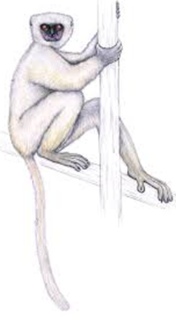
Case Study #2 Silky Sifaka Lemur
Scientific Name: Propithecus candidus

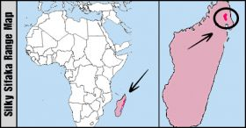
Kingdom: Animalia
Phylum: Chordata
Class: Mammalia
Order: Primates
Family: Indriidae

Species Description: Silky Sifaka weighs between 11 and 14 pounds and measures up to three-and-a-half-feet long. Silkies “fly like angels,” local people say, leaping as far as ten yards from tree to tree.

Habitat: Very restricted range in North-Eastern Madagascar that includes the humid forest belt. This is one of the rarest and most threatened sifakas.
Group Name: Troop
Diet: Herbivore: Consumes roughly 100 species of tree, vine, and parasitic plants. Breakdown of parts of plant consumed consists of; leaves (47.7%), seeds (31.4%), fruits (10.6%), flowers (9.8%), and stems (.5%)
Predators: Human, Fossa, Birds of Prey
Population: Its population size is estimated to range between 100 and 1,000 individuals, while the number of mature individuals is thought to be less than 250.
Status: Critically endangered (one of the world's rarest mammals)
Current population trend: Decreasing

ECOLOGY AND CONSERVATION: There is no taboo or “fady” against eating this species therefore, the Silky Sifaka Lemur is occasionally hunted for food by some ethnic groups in Madagascar. Habitat destruction due to slash-and-burn agriculture also continues to be a primary threat to the species habitat. Some examples of Illegal agriculture can be tied to the logging industry of rosewood and illegal mining for gems in Anjanaharibe-Sud Special Reserve. In recent years, national parks are being established to preserve and increase the number of these endemic species.

Species of Lemur | Description of Habitat | Food Source | Threats to habitat / reasoning for declining trend

BIBLIOGRAPHY
Sifakas. (2010, November 11). Retrieved from https://www.nationalgeographic.com/animals/mammals/group/sifakas/
Case Study #3 Greater Bamboo Lemur
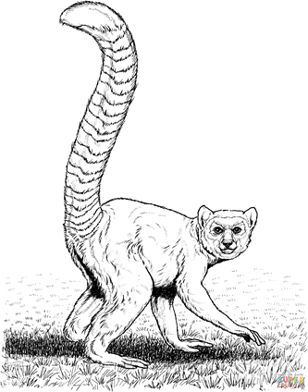
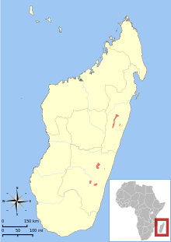
Scientific Name: Prolemur simus

Kingdom: Animalia
Phylum: Chordata
Class: Mammalia
Order: Primates
Family: Lemuridae

Species Description The lemur’s face conceals powerful jaws that are necessary for ripping through tough, living bamboo.
Habitat: Greater bamboo lemurs are found in the eastern humid forests of Madagascar, and are usually found in areas with large woody bamboo species.
Group Name: Troop
Diet: Greater Bamboo Lemurs live almost exclusively on bamboo, like pandas. In the rainy season shoots become 98% of the diet and by the dry season, pith or core of the bamboo provides 89% of the diet.
Predators: Human, Fossa, Birds of Prey
Population: As few as 60 greater bamboo lemurs are left in the wild, and no more than 150, making them among the most critically endangered primates on the planet
Status: Critically Endangered
Current population trend: Rapidly Declining

ECOLOGY AND CONSERVATION: The greater bamboo lemur is threatened by human activities and is currently on the brink of extinction. Hunting by local ethic groups initially depleted their numbers. Habitat destruction, including intensive harvesting of bamboo, is perhaps an even more massive threat. Fragmentation of habitat hits the lemurs especially hard because of their reliance on bamboo. Conservation measures have been put into action by the World Wildlife Foundation, the Aspinall Foundation Madagascar Program, and several other organizations. These include outreach to local communities to build more sustainable practices that will not threaten lemur habitat as much, and active measures such as destroying lemur traps.

Species of Lemur | Description of Habitat | Food Source | Threats to habitat / reasoning for declining trend
BIBLIOGRAPHY
“Greater Bamboo Lemur Videos, Photos and Facts.” Arkive, www.arkive.org/greater-bamboo-lemur/prolemur-simus/.
Case Study #4 Aye-Aye Lemur
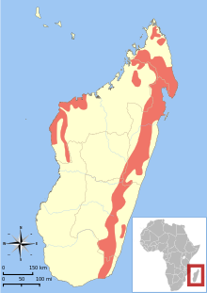
Scientific Name: Daubentonia madagascariensis
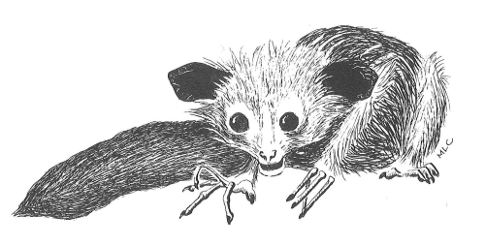
Kingdom: Animalia
Phylum: Chordata
Class: Mammalia
Order: Primates
Family: Daubentoniidae

Species Description: The Aye-Aye Lemur is the largest nocturnal primate endemic to Madagascar. The species has evolved a unique finger in which they will tap on trees up to 8 times per second to find grubs and take them out of the trees. Aye-ayes can cover from 1 to 2 ½ miles each night in order to eat. The idea is to eat what is available so they can store up fat to survive on during the dry season. . Local cultures believe that the Aye-Aye is a sign of death and if it is seen it must be killed, in some cases the entire village will be lit on fire.

Habitat: The Aye-Aye can be found in the higher South-West altitude regions of Madagascar. They enjoy the safety of the canopy of the leaves that spread out above them.
Group Name: Troop
Diet: Omnivore – Insects, Larvae, Fruit. When grubs are unavailable the Aye-Aye will feed on fungi, and nuts.
Predators: Human, Fossa, Birds of Prey (Vulture)
Population: roughly about 1,000 - 10,000 species are left in the wild.
Status: Endangered - Severely threatened from possible extinction in the near future.
Current population trend: Decreasing

ECOLOGY AND CONSERVATION

Today, though, the Aye Aye is also faced with the increasing size of towns and villages that destroy its native habitats, some individuals are forced to invade crops to get food, which often leads to them being shot. They are also severely threatened by deforestation for the logging industry and to clear land for the creation of agricultural plantations. In recent years, national parks are being established to preserve and increase the number of these endemic species.

Species of Lemur | Description of Habitat | Food Source | Threats to habitat / reasoning for declining trend

BIBLIOGRAPHY

Aye-Aye. (2011, May 10). Retrieved from https://www.nationalgeographic.com/animals/mammals/a/aye-aye/

Name: _____________________ Date: ____________

Evaluative Questions

1. The greater Bamboo Lemur and the Aye-Aye may occupy the same habitat. Mark claims that the two species would compete with one another however, his partner Sue stated that the two species would not complete with one another. Which student do you agree with? Explain why.

____________________________________________________________________________________________________________________________________________________________________________________________________________________________________________________________________________________________________________________________________________________________________________________________________________________________________________________________________________________________________

2. Discuss what a variation is and explain why it is essential for a species to have variations at the genetic level?

__________________________________________________________________________________________________________________________________________________________________________________________________________________________________________________

3. Evolution leads to changes in frequency in certain traits found in an ecosystem. Explain the importance of variations within a population.

__________________________________________________________________________________________________________________________________________________________________________________________________________________________________________________

Real-world Scenario

1. Agricultural farming has expanded due to an increase in human population. Predict which species of lemur would be able to survive and explain why you believe this species will be most successful when compared to the other species of lemur.
__________________________________________________________________________________________________________________________________________________________________________________________________________________________________________________

Understanding Tradeoffs

1. Major habitat loss threatens the endemic species of Madagascar. Why is there habitat loss in Madagascar?

___________________________________________________________________________________________________________________________________________________________________________________________________________________________________________________________________________________________________________________________________________________________________________
2. Discuss one local action that can be taken to conserve the species of Lemurs. ___________________________________________________________________________________________________________________________________________________________________________________________________________________________________________________________________________________________________________________________________________________________________________

