Marine Microbiology in the Oligotrophic Ocean
STUDENT WORKSHEET
Giovannoni Lab, Oregon State University

Oligotrophic Simulation developed by Quinn Washburn
Lesson and materials developed by Chris Suffridge, Chih-Ping Lee, Stephen Noell, Quinn Washburn, and Sarah Wolf

Learning Objectives:
- The ocean is the largest biome on Earth, and it is full of life.
- Microorganisms are the most abundant and important inhabitants of the ocean.
- Microbes are diverse (size, shape, and function)
- Microbes form ecosystems where their interactions impact global processes including the carbon cycle.
- We can use models to study and conduct experiments on global processes such as the carbon cycle.

- Research a card

  - Research one of the cards from the game online. Write about it or draw a picture of it and state three interesting facts about the organism, virus, or abiotic factor depicted on the card.

- Simulation 1
  - Predict which class of organisms will accumulate the most biomass. Record your prediction in the datasheet below.
  - Run the simulation.
  - After the simulation has completed, record the number of biomass cubes on each type of card in the datasheet below. The color of the cubes doesn’t matter.
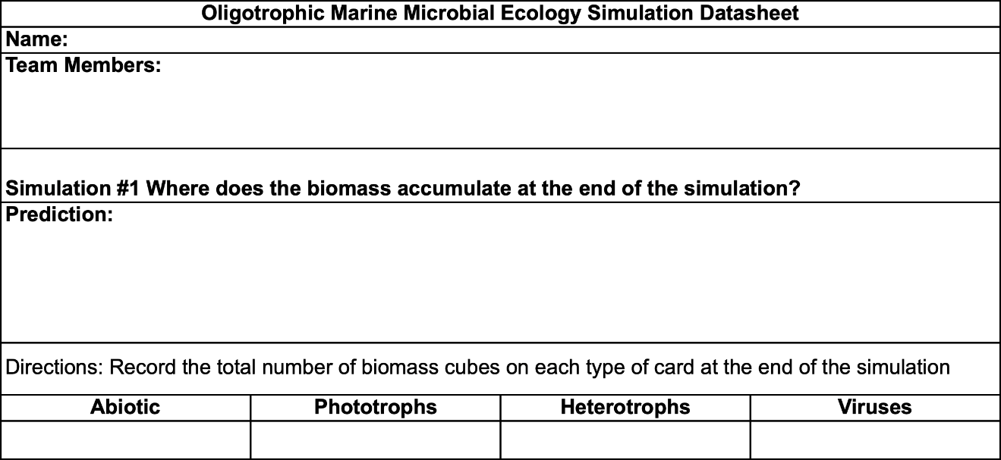
  - Use the data recorded above to make a bar graph to show the distribution of Biomass Cubes, you can draw it here or on a sperate piece of paper.

  - Did your results match your prediction?

  - How did your results match those of your classmates?

  - Why do you think the biomass ended up distributed this way?

- Simulation 2
  - Based on your results from Simulation 1, predict which class of organisms will accumulate the most biomass. Also, predict how the abundance of biomass on each class or cards will change over the course of the simulation. Record your predictions in the datasheet below.
  - Run the simulation.
  - At the end of each round (after each player has played one card), record the number of biomass cubes on each type of card in the datasheet below. The color of the cubes doesn’t matter.
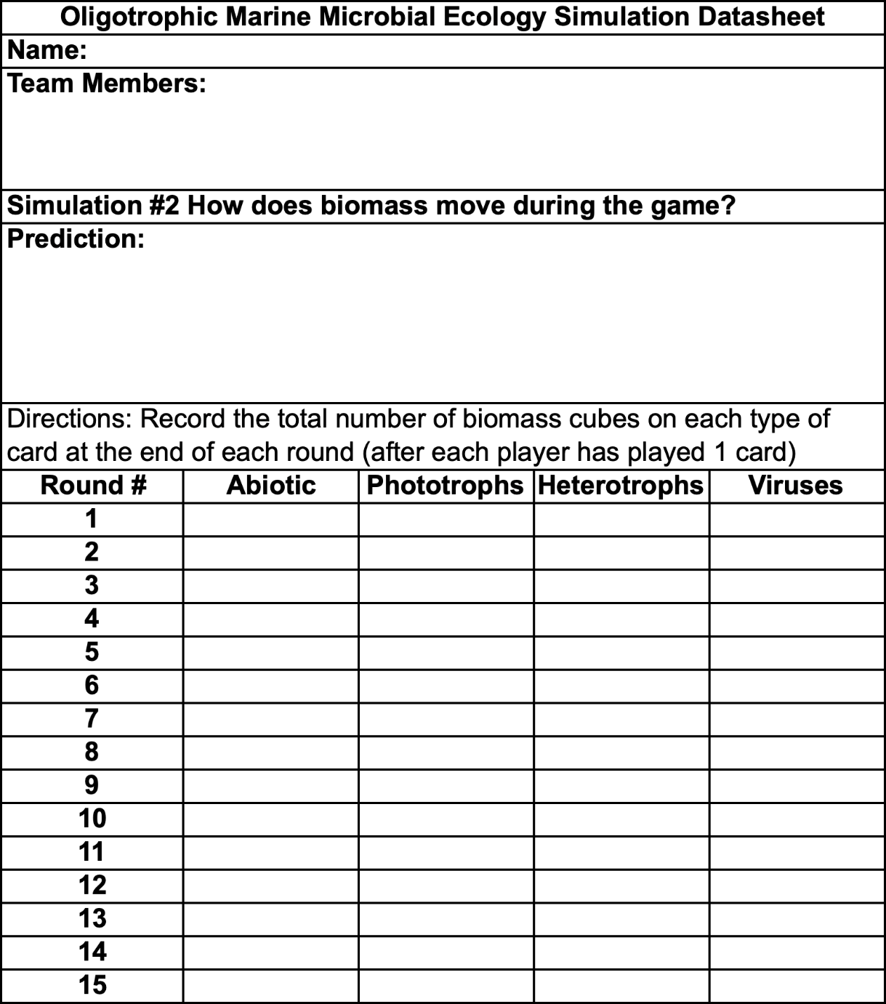
  - How did each type of organism’s biomass change over time?

  - Did your results match your prediction?

  - How did your results match those of your classmates?

  - Why do you think the biomass distribution changes in this way?

  - Describe several specific interactions between organisms that you observed.

- Simulation 3
  - Interactions between organisms are the basis of a stable ecosystem. What would happen if one class of cards was removed from the simulation? Make a prediction and write it on the datasheet below.
  - Run the simulation.
  - At the end of each round (after each player has played one card), record the number of biomass cubes on each type of card in the datasheet below. The color of the cubes doesn’t matter.
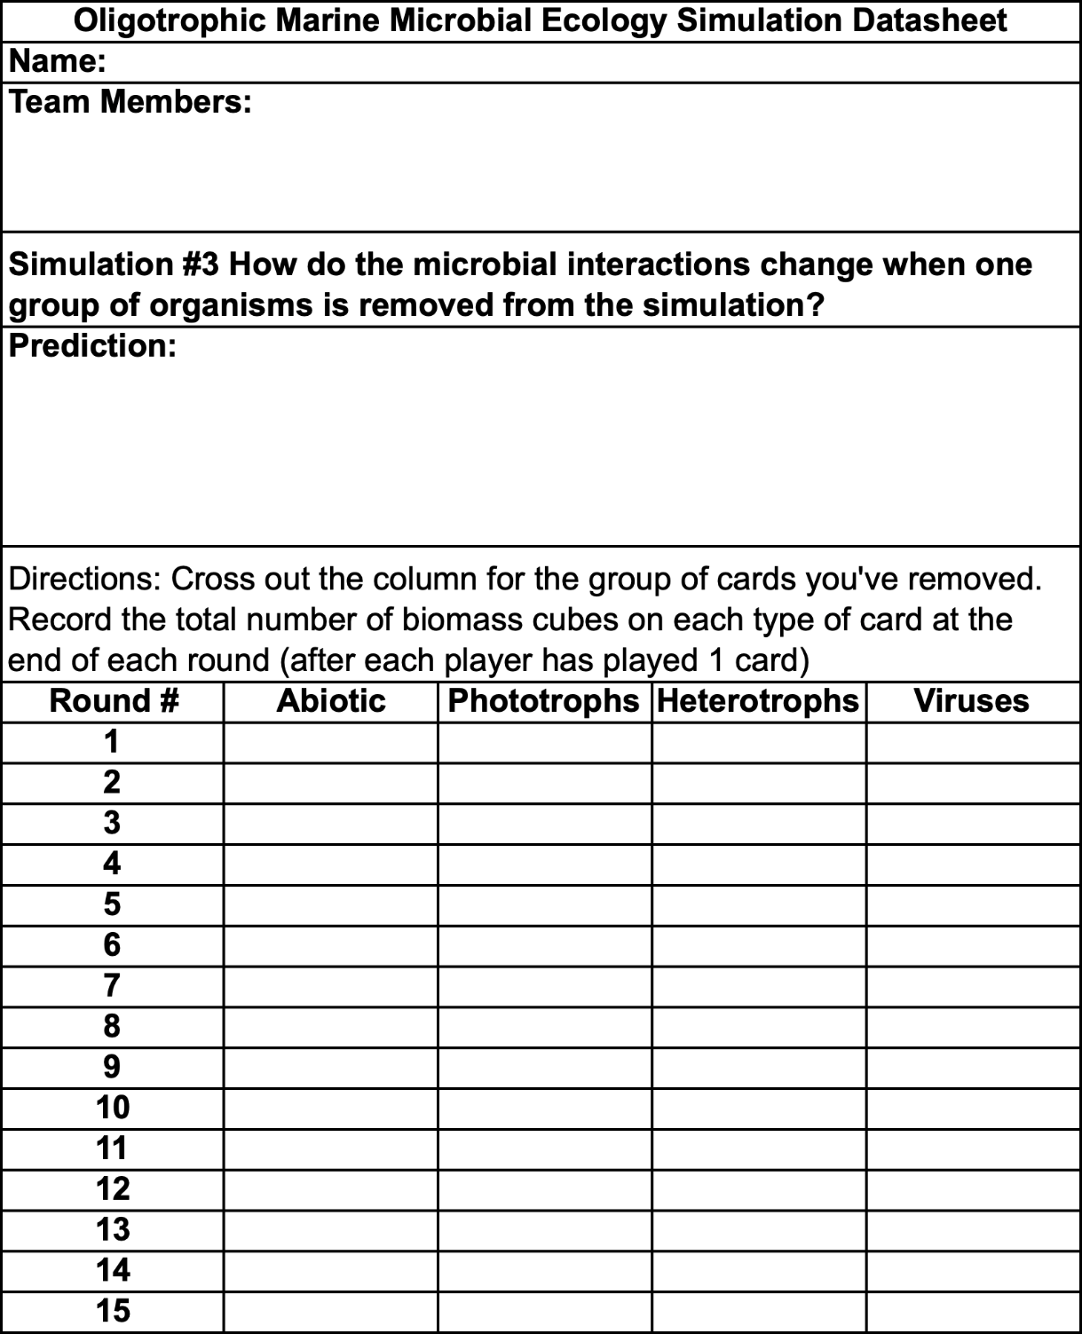
  - Did your simulated ecosystem function the same in simulation 3 as in simulation 2? Describe the differences. What might have caused those differences?

  - How did each type of organism’s biomass change over time?

  - Did your results match your prediction?

  - How did your results match those of your classmates?

  - Why do you think the biomass distribution changes in this way?

- Conclusions: Oligotrophic serves as a model for understanding the role microorganisms play in the cycling of nutrients in the ocean. Use what you have learned through the simulations to answer the following questions about how ocean microbes play an important role in globally.

  - What is at least one reason that marine microorganisms are linked to global climate change?

  - How do ocean microorganisms impact you directly?

  - Explain how microorganisms are essential to marine food webs.

  - How can studying marine microbiology inform change in public policy?

