Identifying Forces Questions

1. A stick of dynamite contains a great amount of
(a) force.
(b) acceleration.
(c) both of these
(d) none of the above
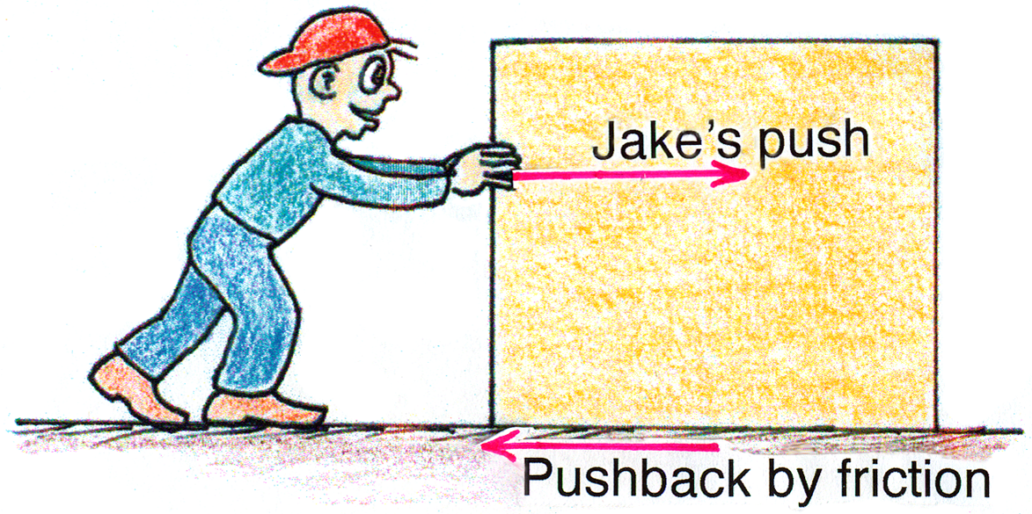
2. Jake exerts a steady horizontal force on a crate initially at rest on a factory floor. It doesn’t move. He pushes harder with 125 N just when the friction on the crate is 110 N. At that moment the net force on the crate is
(a) 0 N.
(b) 15 N.
(c) 110 N.
(d) 125 N.

3. Drop a rock and it falls to the ground due to the force of gravity. In accord with Newton’s third law, the reaction force
(a) is also gravitational.
(b) involves air resistance.
(c) is tiny in comparison.
(d) all of the above

4. Ignoring air drag, the force acting on an upwardly tossed projectile when halfway to the top of its path is
(a) the same as when it reaches the top of its path.
(b) half its weight.
(c) less than half its normal weight.
(d) none of the above.

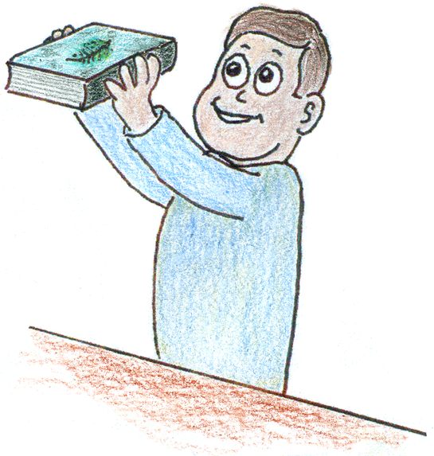
5. Drop a raised book and a feather side by side and you’ll see the book falls faster. Repeat, but place the feather on top of the book and you’ll see that
(a) the book still falls faster.
(b) both fall with equal speeds.
(c) the feather’s fall is chaotic.
(d) the feather doesn’t fall.

6. A fast-flying bumblebee collides head on with an oncoming speeding truck. The force of impact is greater on the
(a) bumblebee.
(b) truck.
(c) the same on both.
(d) Not enough information for an answer.

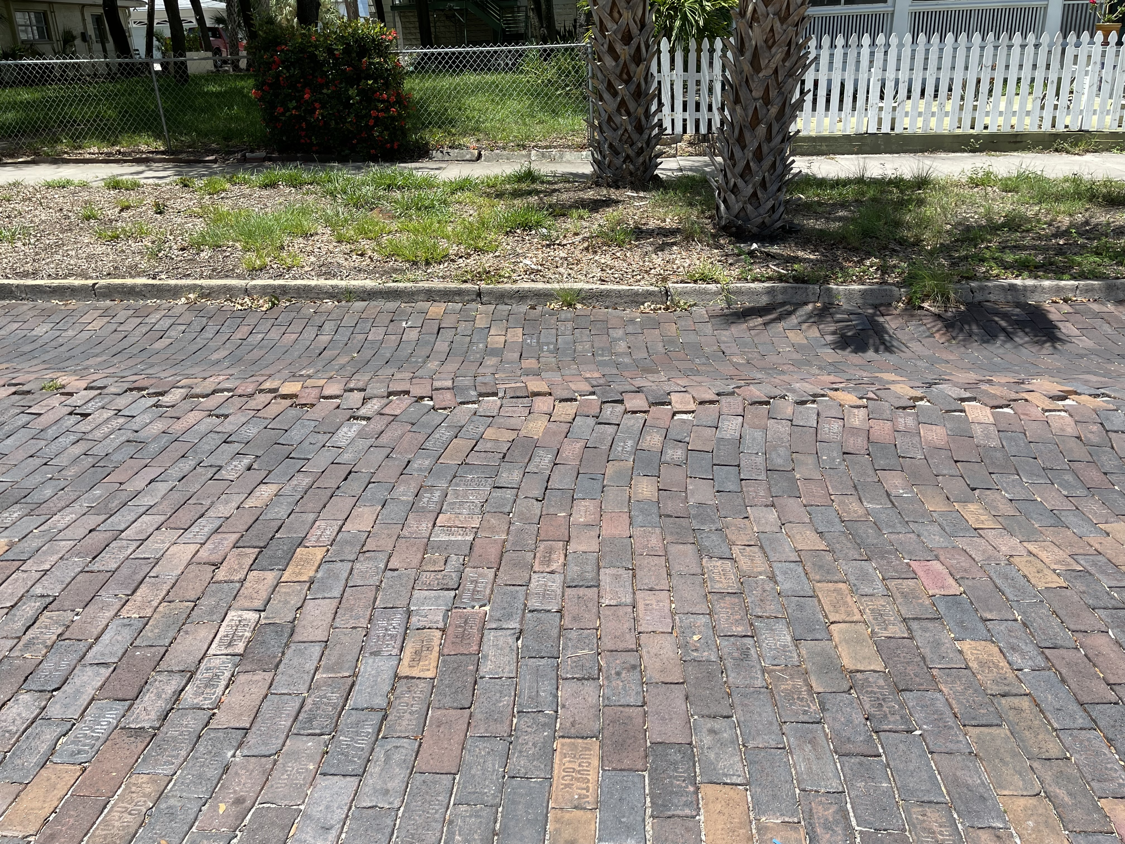
7. The photo shows initially straight-lined bricks on a roadway that have become wavy due to automobile traffic. The wavy bricks support the notion that
(a) brick surfaces don’t lend themselves to the smooth surfaces of physics.
(b) action forces do not always equal reaction forces.
(c) the road supplies the force to push automobiles.
(d) none of the above

8. A boxer’s punch will exert a greater force when it hits a
(a) lightweight opponent.
(b) middleweight opponent.
(c) heavyweight opponent.
(d) about the same on each.

9. For the same force, a cannonball’s speed is greater when fired from a long-barrel cannon than from a short-barrel cannon, due to more
(a) time the force acts.
(b) distance the force covers.
(c) both of these.
(d) none of the above

10. The Sun pulls Earth into a nearly circular orbit by gravitational force. If the Sun hypothetically collapsed to become a black hole, its force on planet Earth would
(a) decrease.
(b) remain unchanged.
(c) increase slightly.
(d) increase tremendously.

Answers: 1 (d), 2 (b), 3 (a), 4 (a), 5 (b), 6 (c), 7 (c), 8 (c), 9 (c), 10 (b).

