Fertility Case Study Packet

You are a doctor working in a fertility clinic. A married couple, Jailyn and Carlos Jenkins, visit you because they have been trying to get pregnant for about two years but have had no success. It is your responsibility to diagnose the cause of their infertility.

First label the following on the drawings below: a) testes, b) ovaries, c) fallopian tubes, d) uterus, e) male gamete or sex cell (sperm), f) female gamete or sex cell (egg), g) zygote, and h) embryo.

Next, think about some potential causes of infertility?

Use the figures below to identify four things that must happen for a successful pregnancy to occur:
Correct answers could include but are not limited to: meiosis to create sperm and egg, ovulation of egg from ovary into fallopian tube, fertilization of egg by sperm, mitosis of zygote cells to create an embryo, differentiation/ specialization of embryo cells to form fetus.

Fallopian tubes

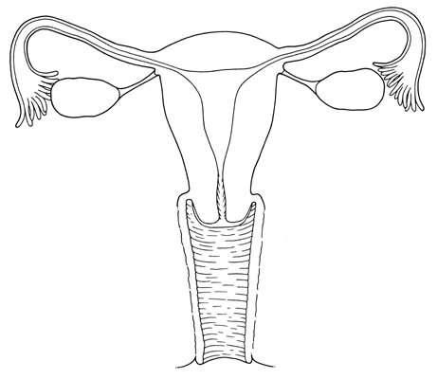
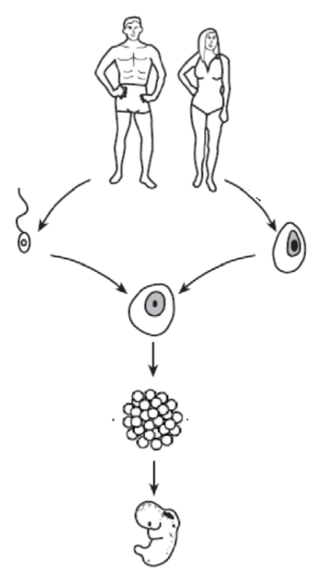

Ovaries

Uterus

Sperm

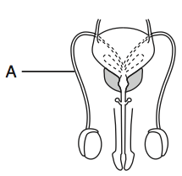
Egg

Zygote

Embryo

Testes

When page 1 is completed, ask your teacher for Clue #1.

Using the information about Carlos and Jailyn’s medical history, answer the following questions:

1. Is there any indication that the cause of infertility is due to environmental factors in Carlos or Jailyn’s life?
If yes, explain what environmental factor might be affecting their fertility.
If no, explain why you do not believe environmental factors may be affecting their fertility or what other information you would need to determine if environmental factors are affecting their fertility.

Correct answers could include but are not limited to:
YES- Carlos drinks alcohol and alcohol may reduce fertility. Carlos is a dental hygienist and may be exposed to x-rays that could affect his fertility.
NO- Carlos traveled outside of the country in the past three months, but this wouldn’t affect their fertility because the couple has been trying to conceive for years. Jailyn and Carlos take medications that shouldn’t affect their fertility, like Advil, Tylenol, or multivitamins. We’d need more information about both Carlos and Jailyn’s potential exposure to environmental factors in their jobs.

2. Is there any indication that the cause of infertility is due to genetic factors?

If yes, explain what genetic factor might be affecting their fertility.
If no, explain why you do not believe genetic factors may be affecting their fertility or what other information you would need to determine if genetic factors are affecting their fertility.
Correct answers could include but are not limited to:
NO- at this point we have no information about genetic factors for Carlos or Jailyn. We would need genetic test results or family histories to know more.

3. Is there any indication that the cause of infertility is due to their medical histories?

If yes, explain what about their medical history might be affecting their fertility.
If no, explain why you do not believe their medical histories are affecting their fertility or what other information you would need to determine if their medical histories are affecting their fertility.

YES- Jailyn hasn’t conceived a child in the past so she may have a condition that prevents it. Carlos hasn’t conceived a child in the past so he may have a condition that prevents it. Both Carlos and Jailyn had surgeries in the past and there might have been complications that affect their fertility- more information on this would be needed.
NO- Jailyn had her appendix removed but this is not associated with reduced fertility. Carlos had surgery on his ACL (knee) which shouldn’t affect his fertility.

After reviewing your patients’ medical history, you decide that you need some additional information about Jailyn’s hormone levels. You order a blood test to assess whether or not her hormone levels are normal.

4. State the two main female reproductive hormones.
Estrogen and progesterone

5. Using your textbook and/or online resources, label each line in the graph below with the correct hormones you identified above:
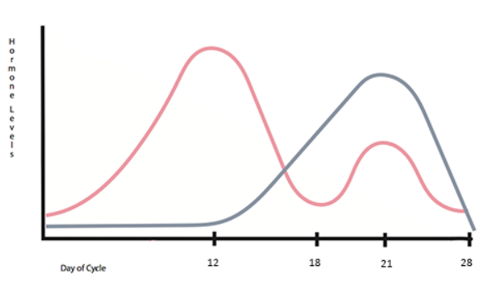
Progesterone
Hormone Levels

Estrogen

14 18 22 28
Day of Cycle

6. List two principal roles of the female reproductive hormones?
Correct answers could include but are not limited to:
Spike in estrogen causes ovulation. Estrogen controls the growth of the lining of the uterus during the first part of the cycle. Progesterone causes the uterine lining to thicken after ovulation.

7. Name the organ in the female reproductive system that produces hormones.
Ovaries.

8. Describe on possible way that hormone levels could be the cause of infertility.

Correct answers could include but are not limited to:
Without a spike in estrogen, an egg might not ovulate. Without proper estrogen levels, a uterus might not be able to carry a pregnancy due to a lack of uterine lining.

After completing this page, ask your teacher for Clue #2, your patient’s hormone test results!

Use the graph of a typical menstrual cycle to help you answer questions 9-13 below:
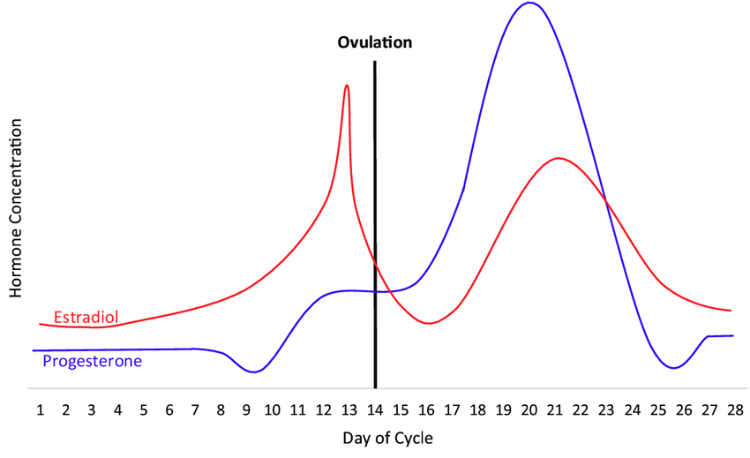
Estrogen

9. What is ovulation? When the egg leaves the ovary and travels into the fallopian tube.

10. What causes ovulation? (Hint: What are the hormones levels just before ovulation?)

A spike in estrogen levels.

11. On what day does ovulation occur? 14

12. Does Jailyn have the normal hormone levels to cause her to ovulate?

Students could argue for yes or no.

13. Do you think that Jailyn’s hormone levels are the cause of infertility? Why? Why not?
Correct answers could include but are not limited to:
NO- Jailyn’s hormone levels mimic the levels of regular hormone levels/ Jailyn’s graph looks similar to the normal graphs, so her hormone levels are not the cause of infertility.
YES- the unit/ scale on the hormone graphs are incomplete or vague so it could be misrepresenting the data. In the graph on this page, the highest level of progesterone is higher than the highest level of estrogen, but Jailyn’s progesterone levels never exceed her estrogen levels.
(The key here is for students to critically analyze the graphs and support their claims with evidence.)

After looking into Jailyn’s hormone levels, you decide to check if her anatomy (body parts) are normal. You order a pelvic ultrasound. Obtain Clue #3 from your teacher and move on to the next page.
Using the results from Jailyn’s ultrasound in Clue #3, answer questions 14-17.

14. Do you have any concerns about the structure of Jailyn’s uterus? Why? Why not?
Correct answers could include but are not limited to:
NO- The actual structure of Jailyn’s uterus is normal. The growths of excess tissue do not seem to be affecting the shape of her uterus.
YES- There are two areas on her uterus that have abnormal tissue growth.

15. Do you have any concerns about the appearance of Jailyn’s fallopian tubes? Why? Why not?
Correct answers could include but are not limited to:
NO- The actual structures of Jailyn’s fallopian tubes are normal. Although there is an abnormal growth blocking one fallopian tube, the other fallopian tube is not blocked and an egg and sperm could still travel through it.
YES- One of Jailyn’s fallopian tubes is completely blocked from her uterus by the abnormal growth. Although the other fallopian tube is not blocked, having one blocked tube could be enough to cause their infertility.

16. Do you have any concerns about the positions of Jailyn’s ovaries? Why? Why not?
Correct answers could include but are not limited to:
NO- The actual positions of Jailyn’s ovaries are normal.
YES- There is abnormal tissue growth on one ovary. The ovary is where the oocytes are matured and it is in charge of maintaining the proper hormones, and this growth may be impeding the ovary from doing that. The ovary without an abnormal growth is blocked by abnormal growth on the fallopian tube of that side.

17. Based on Jailyn’s ultrasound, is there anything about her reproductive anatomy that may be causing her infertility? Explain why you believe her anatomy may or may not be contributing to her infertility.

Correct answers could include but are not limited to:
NO- Even though one ovary has an abnormal growth and one fallopian tube is blocked, there is still one fallopian tube that is not blocked and one ovary that doesn’t have abnormal growth on it. This should be enough to be fertile.
YES- Having an abnormal growth on one ovary may be enough to not allow the ovaries to create and maintain the necessary levels of hormones. The ovary with the abnormal growth may not be able to ovulate eggs, and the other ovary is blocked from the uterus by abnormal growth in the fallopian tube, so no viable eggs will ever be able to meet and be fertilized by sperm.

While you were explaining Jailyn’s hormone lab results to the couple, Carlos mentions that 10 years ago he was a bodybuilder. Carlos tells you he knows all about the male reproductive hormone, testosterone, because that is the main ingredient in steroids. He confesses to using steroids briefly when he participated in bodybuilding competitions 10 years ago. Do you think Carlos prior incidents of taking steroids could affect his fertility?

Reflect on Carlos’s situation and record your answer below.
Here students record any prior knowledge or misconceptions they may have about steroid use.

Then get Clue #4 from your teacher.

18. Where is testosterone normally produced in the male? Testes.

19. Testosterone is required for the production of what key part of the male reproductive system? Sperm

20. You decide to test Carlos’s hormone levels to determine if his anabolic steroid use from 10 years ago is still affecting his testosterone levels today. Given what you know about anabolic steroids, would you expect Carlos to have higher-than-normal or lower-than-normal testosterone production? Why? Or why not?
Correct student answers could include but are not limited to:
Anabolic steroids mimic testosterone. Since Carlos took steroids, he would have higher levels of testosterone. OR Clue 4 says the effects of steroids can last for a year after taking them. Since Carlos took steroids 10 years ago, they wouldn’t affect his hormone levels. OR Clue #4 says that when a man takes anabolic steroids, his body thinks it already has enough testosterone so it stops making its own. Because of this, Carlos would have lower than normal testosterone levels.

After completing the questions 18-20, see your teacher to obtain Clue #5 showing information on the effect of steroids.
21. Using the information from Clue #5, draw on the diagram to show why Carlos’s hormone levels are not normal. Explain your answer below.

Correct answers could include but are not limited to:

Clue #5 states that due to Carlos’s job, he is exposed to a lot of BPA. BPA is an endocrine disrupter, meaning it interferes with the normal production of hormones in the body. Because BPA is shaped very similarly to testosterone, it is possible that BPA would bind to the testosterone cell receptors instead of testosterone. Clue #5 said that when a cell’s testosterone receptors are full, it signals to the rest of the body to stop producing testosterone. When BPA is filling up testosterone’s cell receptors, the cell will think its receptors are full of testosterone and signal to the body to stop making testosterone. Because Carlos is continually exposed to BPA through his job, his body is always exposed to BPA which fills his cell’s testosterone levels. Therefore, his body will not be making more testosterone causing him to have very low testosterone levels.

Before deciding on a treatment plan for Carlos and Jailyn, you decide to run one more test. You want to know if there are any genetic factors that may be affecting Jailyn’s fertility. You obtain a sample of Jailyn’s DNA and use gel electrophoresis to evaluate a specific gene involved in infertility.

22. Describe how gel electrophoresis work. Your answer should include the terms “DNA fragments”, “size”, and “speed”.
Correct answers could include but are not limited to:
Gel electrophoresis is a lab technique that separates DNA fragments by size. The size of a DNA fragment determines the speed with which it will travel. As the electric current compels the DNA fragments to move across the gel, larger DNA fragments will move slower than smaller DNA fragments.

Below are the gel electrophoresis results from Jailyn compared to nine other patients. Jailyn is Patient 4.

Patient: 1 2 3 4 5 6 7 8 9 10

Gel Electrophoresis Analysis
- Patient 1, 3, and 10 were originally unable to get pregnant because of problems with their partner’s sperm.
- Patients 2 and 8 had a hormonal imbalance and needed to take hormone supplements in order to get pregnant.
- Patients 7 and 9 had abnormal menstrual cycles and had to take hormonal supplements in order to get pregnant.
- Patient 6 was diagnosed with a condition called Premature Ovarian Failure. Patient 6 was able to get pregnant using in-vitro fertilization (IVF).
- Jailyn is Patient 4

23. Which patient would you expect to have a similar diagnosis to Patient 4? Why?
Correct answers may include but are not limited to:
Patient 6 has DNA fragments/ gel electrophoresis results almost identical to Patient 4.

Use the gel electrophoresis results and Clue #6 to answer the following questions:

24. What gene(s) may be altered in Patient 4 and Patient 6? PTHB1 and ADAMTS19

25. Do you think that any of the other patients besides Patient 4 and Patient 6 have an altered version of this gene? Why or why not?
Correct answers may include but are not limited to:
YES- Based off the gel electrophoresis image, it looks like Patient 1 or Patient 10 have DNA fragments that are roughly the same size as Patient 4 and 6.
NO- Based off the gel electrophoresis results, no other patients have DNA fragments that match exactly with Patients 4 & 6.

26. Based on Jailyn’s gel electrophoresis results, do you think there is a genetic component to her infertility? If yes, what is it? If no, why not?
Correct answers may include but are not limited to:
YES- Both Jailyn (Patient 4) and Patient 6 were unable to get pregnant naturally. Patient 6 was diagnosed with a condition called “Premature Ovarian Failure” which, according to Clue 6, genes “PTHB1” and “ADAMTS19” have been associated with. According to the gel electrophoresis results, Jailyn may share these genes with Patient 4, causing her own infertility.
NO- Although Jailyn and Patient 6 share some similar DNA fragments, this is not enough to definitively state that she has the genes associated with Premature Ovarian Failure. Clue 6 admitted that the link between the genes PTHB1 and ADAMTS19 needs to be studied further to be verified. Clue 6 mentioned that just because “you have a certain sequence in a region of DNA does not necessarily mean you will get the disease”.

Now consider all of the information you’ve learned about Carlos and Jailyn from this case study and make an official diagnosis. You must state whether you think their infertility is primarily due to:
- Carlos’s testosterone levels,
- Jailyn’s endometriosis, or
- Jailyn’s genetic condition.

Once you’ve made your decision, fill out the official Doctor’s Notes and Diagnosis form on the next page.

RGH Laboratory
Reproductive Specialists
2020 Rochester Road
East Irondequoit, NY 14618

Doctor’s Notes and Diagnosis

Patient name(s): ___________________________________________________

Primary cause of infertility: ___________________________________________

Treatment Plan

List three things that Jailyn and Carlos can do to improve their chances of getting pregnant:

- _____________________________________________________________

- _____________________________________________________________

- _____________________________________________________________

Doctor’s signature

_________________________________________________________

