Name: _________________________________ Date: _________________________

The Story of Palm Oil
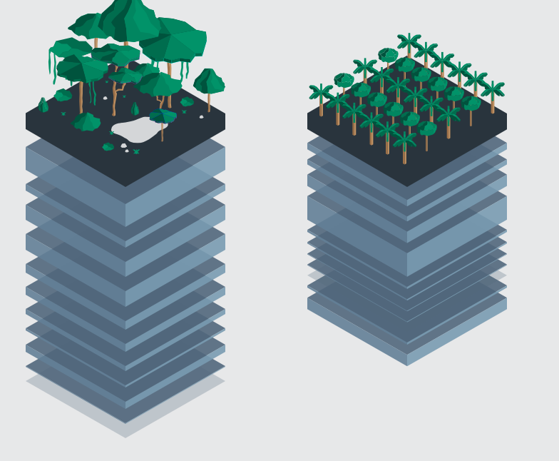
Directions: A stakeholder is a person, group or organization that has interest in or concern about an issue. Using the interactive website below, gather information about the palm oil industry and the various positions of different stakeholders. Answer the discussion questions in complete sentences to express your ideas.

https://www.theguardian.com/sustainable-business/ng-interactive/2014/nov/10/palm-oil-rainforest-cupboard-interactive

Engage: Watch the video on Supriyono and read the story about Laskar. Supriyono is a 40-year-old palm oil farmer from the Dosan village. Laskar Harianja is a 30-year-old farmer on a pineapple plantation.

- Describe the different experiences that Supriyono and Laskar Harianja have had with the palm oil industry.
_______________________________________________________________________________________________________________________________________________________________________________________________________________________________________________________________________________________________________________________________________________________________________________________________________________________________________________________________________________________________________________________________________________________________________________________________________________________________________________________________________________________________________________________________________________________________________________________________________________________
- How has the industry impacted them? Support your ideas.
____________________________________________________________________________________________________________________________________________________________________________________________________________________________________________________________________________________________________________________________________________________________________________________________________________________________________________________________________________________________________________________________________________________________________________________

Evaluation
- Discuss the effect the palm oil industry has on biodiversity. Support your claim with information from the interactive webquest.
_____________________________________________________________________________________________________________________________________________________________________________________________________________________________________________________________________________________________________________________________________________________________________________________________________________________________________________________________________________________________________________________________________________________________________________________________________________________________________________________________________________________________________

2. Is the rainforest more valuable dead or alive? Support your answer.
______________________________________________________________________________________________________________________________________________________________________________________________________________________________________________________________________________________________________________________________________________________________________________________________________________________________________________________________________________________________________________________________________________________________________________________________________________________________________________________________________________________________________

Closing Ideas:
1. Why is biodiversity essential to both the human population and wild places? Provide examples. _____________________________________________________________________________________________________________________________________________________________________________________________________________________________________________________________________________________________________________________________________________________________________________________________________________________________________________________________________________________________________________________________________________________________________________________

2. Discuss the tradeoffs (at least one pro and one con) of the palm oil industry. Use examples from the interactive website.
_____________________________________________________________________________________________________________________________________________________________________________________________________________________________________________________________________________________________________________________________________________________________________________________________________________________________________________________________

Think Globally, Act Locally
Observation: What have you learned about how you are connected to the palm oil industry as a consumer?

Local Action: What are some actions you could take in your own life to affect the issues you’ve uncovered about this industry?

______________________________________________________________________________________________________________________________________________________________________________________________________________________________________________________________________________________________________________________________________________________________________________________________________________________________________________________________________________________________________________________________________________________________________________________________________________________________________________________________________________________________________________________________________________________
______________________________________________________________________________________________________________________________________________________________________________________________________________________________________________________________________________________________________________________________________________________________________________________________________________________________________________________________________________________________________________________________________________________________________________________________________________________________________________________________________________________________________________________________________________________

