**Welcome to the *Going Viral!* Kit**

We are delighted to provide you with this resource to enrich your science lessons. This kit was designed to be an extension to the curriculum about viruses, the human immune system, and herd immunity. Its use is intended for students in 8th grade and higher in a supervised classroom setting. The activities are designed to be student-centered, guided inquiry explorations. Paired students work at their own pace, while you take on the role of facilitator and guide.

This kit covers the scientific practices of Developing & Using Models; Analyzing & Interpreting Data; Using Mathematics & Computational Thinking; Constructing Explanations & Designing Solutions; and Engaging in Evidence Based Reasoning. (<https://www.nap.edu/read/13165/chapter/7#50>)

We strongly recommend that you try the kit before using it with your students. In the following pages, you will find all the information needed to successfully carry out this activity.

**Table of Contents**

Background _ _ _ _ _ _ _ _ _ _ _ _ _ _ _ _ _ _ _ _ _ _ _ _ _ _ _ _ _ _ _ _ _ _ _ _ 1

Going Viral STEM Kit Contents _ _ _ _ _ _ _ _ _ _ _ _ _ _ _ _ _ _ _ _ _ _ _ _ _ _ _ _ 2

Before using the kit _ _ _ _ _ _ _ _ _ _ _ _ _ _ _ _ _ _ _ _ _ _ _ _ _ _ _ _ _ _ _ _ _ 3

Teacher Safety Note _ _ _ _ _ _ _ _ _ _ _ _ _ _ _ _ _ _ _ _ _ _ _ _ _ _ _ _ _ _ _ _ 3

Getting your students ready _ _ _ _ _ _ _ _ _ _ _ _ _ _ _ _ _ _ _ _ _ _ _ _ _ _ _ _ _ 4

Using the kit _ _ _ _ _ _ _ _ _ _ _ _ _ _ _ _ _ _ _ _ _ _ _ _ _ _ _ _ _ _ _ _ _ _ _ _ 5

Section Notes

Part 1: Germs

Part 2: How Invisible Are Microbes?

Part 3: Effects of Microbes

Part 4: Immune Response

Part 5: Herd Immunity

Clean Up

Packing Instructions

Suggested Class Discussion Questions

Appendix

Sodium Hydroxide Solution 0.3 M – 6.0 M Safety Data Sheet Information

Phenolphthalein Alcohol Solution Safety Data Sheet Information

Buffer Solution pH 2.0 Safety Data Sheet

**Background**

The idea for Going Viral was developed in early 2018, when the author, an honors student at our university, set out to bridge a deepening knowledge gap in the public’s understanding of bacteria, viruses, vaccines, and the immune system. Most notably, she was impassioned by the antivaccination movement. The author saw that these anti-vaccine campaigns were based upon misunderstandings of the complex immune system and the functionality of vaccines that help our bodies fight off dangerous pathogens. She felt that more people should have access to knowledge that would help them understand the way that their immune system and vaccines worked. Thus, for her honors thesis project, she decided to develop a kit that would help educate young scientists on important microbiological concepts that would give them tools to make educated decisions about their health and help them understand more about their immune system, bacteria, and viruses. This project became even more timely as the SARS-CoV-2 virus began to spread globally in early 2019. The COVID-19 pandemic further highlighted the importance of a more widespread understanding of immunity, pathogens, and vaccines so that people can feel confident making choices for the betterment of their health and others around them.

The Going Viral kit will help students understand herd immunity, how vaccines work, and will touch upon the connection between illness and pathogens that cause it. As they work though the kit, students will gain an understanding of the existence and relative size of bacteria and viruses, and they will map out an immune response to a dangerous pathogen. It is designed as an engaging guide to help students understand where “germs” come from, what they are, and how they interact with the beautifully complex immune system that is at work inside of each of us every single day. By the end of the kit, students will be armed with knowledge to help them develop informed opinions and make educated decisions about their health. They will walk away new perspective on the tiny, invisible microorganisms that we interact with every single day.

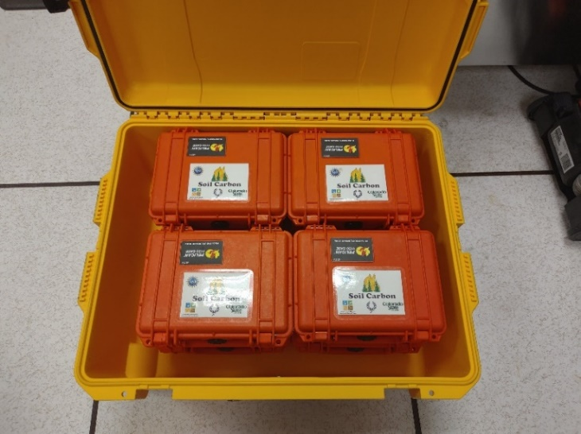**Going Viral STEM Kit Contents**

An example of a classroom set of 15 kits (orange) is inside one large dark case (or two smaller yellow cases). It also includes a teacher’s kit (grey) with extra supplies in case they are needed, and this User’s Guide.

**Each individual kit contains:**

* 2 pipets (labeled 1 & 2)
* 2 small vials (labeled 1 & 2)
* 2 solution bottles (labeled Solution 1 & Solution 2) **These are different depending on which kit number it is!**
* Sickness Indicator dropper bottle
* Small Petri dish
* Digital microscope
* Microscope slide
* Calculator
* Colored pencils
* Bag of microbe cards (1 size chart, 3 category labels, 16 microbes)
* 7 3D printed game pieces (2 pathogens, 1 dendritic cell, 3 T cells, 1 memory cell, and 1 killer cell)
* Immune Response cards (A-F)
* Immune Response simulation board
* Going Viral booklet

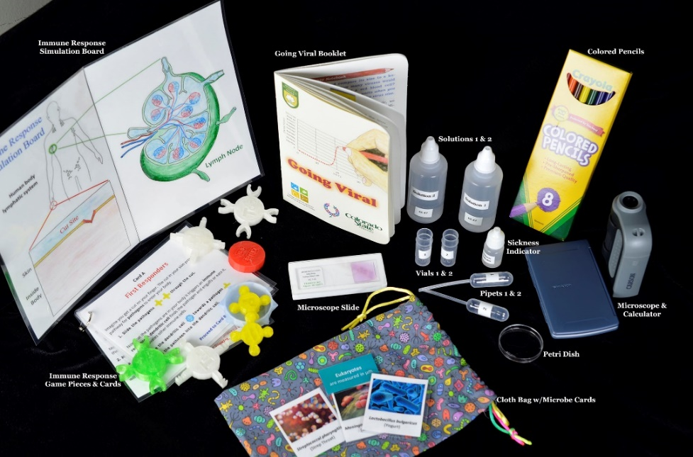

**Before using the kit**

1. Try the kit or go through the booklet before using it with your students.
2. Ensure you have at least 90 uninterrupted minutes to carry out all the activities and class discussion at the end. You can also divide the activities into multiple days, but will need to identify a good stopping point each day.
3. Make sure to have the following supplies on hand:

* Water (to rinse out vials, pipets & Petri dish)
* Paper towels
* **Safety goggles**
* Science Notebook

1. Arrange your classroom/ working area in way that provides students with enough table space to accommodate their tools so that they can work comfortably.
2. Sketch two graphs on the board for students to record their infection rate data from sections 1 & 5:

Infected

Uninfected

Number of Humans

**Test 2**

Infected

Uninfected

Number of Humans

**Test 1**

**Teacher Safety Note**

This kit involves the use of three solution. Because there are such small amounts being used in a controlled environment, the risk to student health is minimal, but it does exist.

* Some solution 1 and 2 can be a 0.5 molar solution of sodium hydroxide (NaOH), which is a strong base.
* Some solutions 2 can be composed of a pH 2 buffer solution, which is a strong acid.
* The sickness indicator is 0.03% phenolphthalein indicator solution, which is flammable.

The specific solutions in each kit are:

|  |  |  |
| --- | --- | --- |
| Kit # | Sol 1 | Sol 2 |
| 1 | NaOH | DI |
| 2 | DI | NaOH |
| 3 | DI | 2 pH |
| 4 | DI | 2 pH |
| 5 | DI | 2 pH |
| 6 | DI | 2 pH |
| 7 | DI | DI |
| 8 | DI | 2 pH |
| 9 | DI | 2 pH |
| 10 | DI | 2 pH |
| 11 | DI | 2 pH |
| 12 | DI | DI |
| 13 | DI | 2 pH |
| 14 | DI | 2 pH |
| 15 | DI | 2 pH |

Since students will not know which of their samples has NaOH or pH 2 buffer during the activity, ALL samples must be treated as though they contain a potentially harmful to skin and eyes substance. Safety glasses or goggles must be worn whenever students are handling the chemicals. Please be sure to monitor student behavior and prevent incidents.

The Safety Data Sheets for these can be found in Appendix 1 at the end of the guide.

**Getting your students ready**

1. Group your students into working pairs.
2. Tell students about the safety guidelines to be followed throughout the activity.
3. Explain that they will be completing a self-guided, collaborative, hands-on activity, for which all instructions and materials are contained inside the kit.
4. When they open the kit, they will find a booklet that will walk them through each activity. We recommend that each pair of students rotate in reading out loud for a better understanding of the content.
5. Our kits encourage students to record their observations, results, and reflections in a science notebook. Students should start by opening their science notebooks to a new page. Title this new entry as “Going Viral”, include the date, and the name of their partner.

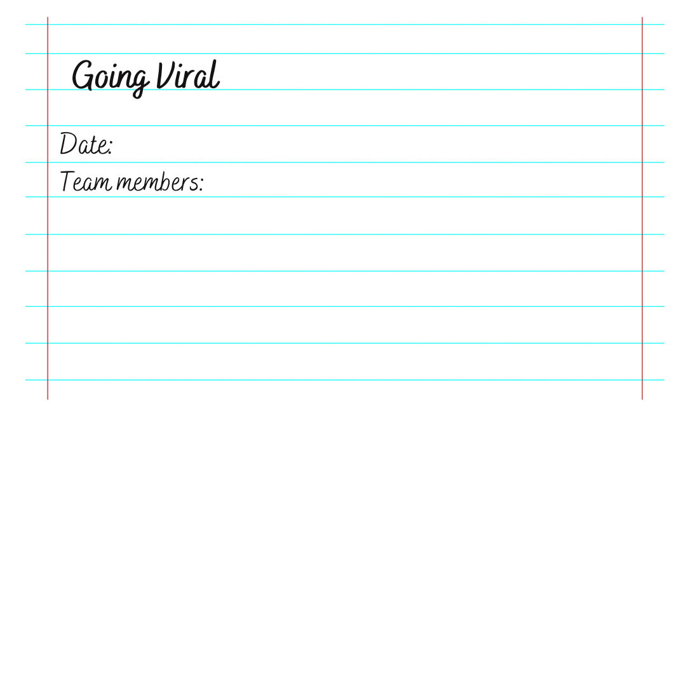

1. Science notebook prompts are distributed throughout the booklet and are easily recognized by a pencil icon. This icon indicates that the students should stop and respond to the prompt in their notebooks.



1. Tell students how much time they have available to complete all the activities and what you expect them to gain from this experience.

**Using the kit**

1. Have each pair of students obtain a kit, a pair of safety glasses and paper towel.
2. Students should then open the kit and take out the Going Viral booklet and begin reading. Advise them to read the text rather than just looking at the images.
3. Students should be allowed to proceed at their own pace, but keep track of time.
4. Support students by walking around the classroom, triggering curiosity with open-ended questions, and encouraging them to keep on track.

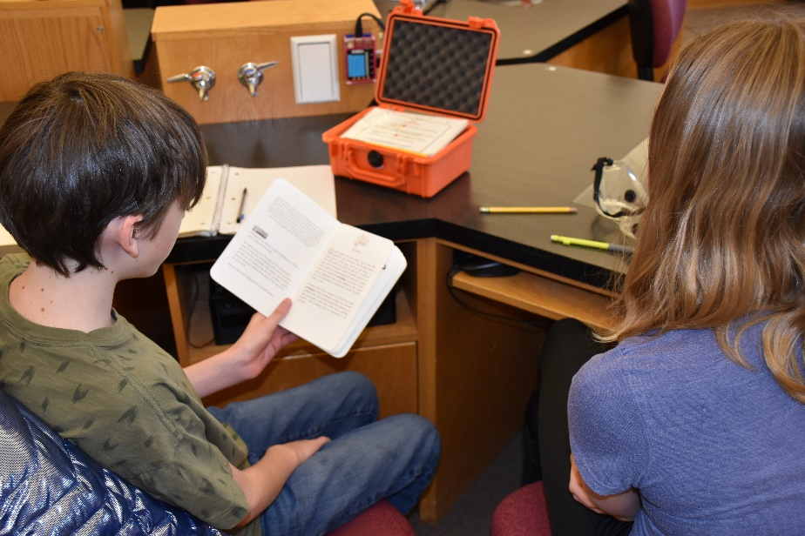

**Section Notes**

**Part 1: Germs**

1. This part includes the use of a dilute solution of sodium hydroxide (NaOH), Distilled Water (DI) and Phenolphthalein (Sickness Indicator). Since students will not know which kit has the NaOH, **ALL students MUST wear safety glasses or goggles** whenever they are working with the solutions in the kit!
2. If not all kits are going to be used for a given class, make sure that kits #1, #2 & #3 are used for sure so that this activity works as intended.
3. Students will be walking around the room transferring 2-3 drops of their “saliva” with other “humans”. Encourage students to gently squeeze the pipette to mix the solution thoroughly before transferring to the next group.
4. Make sure that groups **do not** clean out their human vials #1 until ALL groups have had a chance to swap “saliva” with at least three other groups.

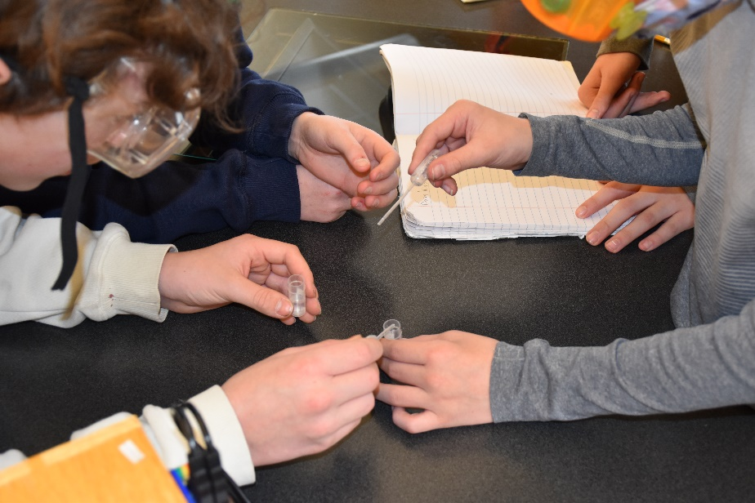

1. Since we are using such small quantities and concentrations, it is safe to dispose of the used chemicals down the drain with water.
2. Once students rinse their pipette, vial, and petri dish, they can take off their safety glasses until the next time they are asked to use the solutions.
3. Use the graph for Test 1, to have students register if their human was infected or not infected.
4. Some students may need help calculating the percent infected. Be sure to circulate around the room to help students who may need it.

**Part 2: How Invisible Are Microbes?**

1. Students should be introduced to the proper use of the digital microscope in order to get the full experience and be able to see the specimens.
2. 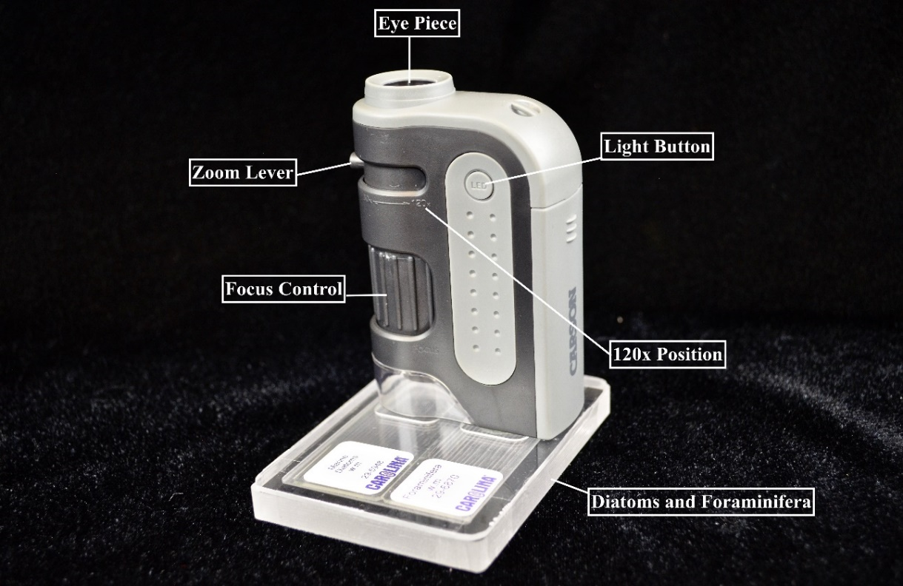To turn on, press the LED button. Place the viewing object directly below the objective lens. Adjust the zoom lever to the desired level of magnification (60-120x). Rotate the focus control until the image is clear.
3. The human hair sits on top of the red blood cells on the slide, so both items will not be in focus at the same time. Some students may struggle figuring this out.
4. On the Science Notebook prompt of pg. 9, students must use the number of blood cells that they observe in the hair sample to estimate the width of a single blood cell. The correct number of observed blood cells is between 6-8 cells. This will give students a final result that a human blood cell is somewhere between 6-9 μm.

**Part 3: Effects of Microbes**

1. At first, students should only remove the picture cards from the cloth bag in order to sort the cards solely by shape and structure. There is no right or wrong answer for this! Students should be encouraged to explore several possibilities, as scientists have done throughout time.
2. After students have studied the pictures long enough, they should pull out the category headings: bacteria, viruses, eukaryotes and identify their three groups.
3. Finally, there is a size chart and the headings have a clue about the general size of those microbes to help them improve the sorting.
4. Remind students that viruses are extremely small and measured in nanometers (nm). Bacteria can be a variety of sizes measured in micrometers, but are typically a lot smaller than eukaryotes, which are also measured in micrometers. They will be asked to locate where the blood cell size that they calculated in Part 2 falls in the size chart and that will help them identify bacteria from eukaryotes.
5. The correct categorization is as follows:

*Viruses*

Rhinovirus (Common Cold)

Flavivirus (Zika virus)

Bacteriophage (virus that infects bacteria)

Influenza (Flu)

Betacoronavirus (COVID-19)

Morbillivirus (Measles)

Varicella zoster (Chicken Pox)

*Bacteria*

Staphylococcus (Staph infection)

Meningococcal meningitis (infection of the brain and spinal cord)

Streptococcal pharyngitis (Strep Throat)

Bacteroides (Healthy Digestion)

Clostridium tetani (Tetanus)

Mycobacterium tuberculosis (Tuberculosis)

Lactobacillus bulgaricus (Yogurt)

*Eukaryotes*

Saccharomyces cerevisiae (Bread Baking)

Plasmodium (Malaria)

Giardia (Diarrheal disease)

Microsporium (Athlete’s Foot)

1. On the Science Notebook prompt of pg. 13, students will need a clear understanding of the units, nm and μm. They will need to transform the units in order to get the correct answer of how many viruses can fit in the diameter of a red blood cell (from their previous calculation).
2. Make sure students observe and identify the difference between a healthy and a damaged cell. Ask students to draw and label them, using color and adding some notes from their observations.

**Part 4: Immune Response**

1. First, students will follow a simulation of the immune system. Be sure both students are handling the game pieces and following along with the simulation.
2. **Note**: The simulation does not include the entire immune response. It is designed to explain why a second exposure to a pathogen leads to a stronger, faster response. The entire immune response includes many components not covered in this activity kit.
3. Students shall be careful when attaching the Pathogens to the T Cell or Memory Cell pieces so they don’t break. Help students take them apart if necessary.
4. By the end of this section, students should be able to identify some components of the immune system, model an immune response, and compare and contrast a first and second exposure to a pathogen using graphs and a simulation, as well as how a vaccine impacts an immune response.

**Part 5: Herd Immunity**

1. Again, students are **REQUIRED to wear** **safety glasses or goggles** while handling the chemicals.
2. Make sure that groups **do not** clean out their human vials #2 until ALL groups have had a chance to swap “saliva” with at least three other groups.
3. Since we are using such small quantities and concentrations, it is safe to dispose of the used chemicals down the drain with water.
4. Students shall rinse their pipette, vial, and petri dish and can then take off their safety glasses.
5. Use the graph for Test 2, to have students register if their human was infected or not infected. Students will calculate the ratio of infected humans from the vaccinated simulation to the infected humans from the unvaccinated simulation (done in Part 1).

**Clean Up**

1. All the microscope light needs to be turned off.
2. The used chemical solutions are safe to be poured down the sink drain with running water.
3. The caps on all of the dropper bottles are on tightly to avoid leaks.
4. Solutions #1 & #2 go back into the correct kit (each bottle is labeled).
5. Thoroughly rinse and dry the pipets, Petri dishes and vials. All items MUST be dry before closing kit!
6. All microbe cards get put back into the cloth bag.
7. Wipe down work area with a damp paper towel and throw all trash away.
8. Students thoroughly wash their hands.

**Packing Instructions (For Pelican Cases)**

1. Place the calculator, microscope slide, Immune Response game pieces, Solutions #1 & #2 bottles and colored pencils into the case as shown.

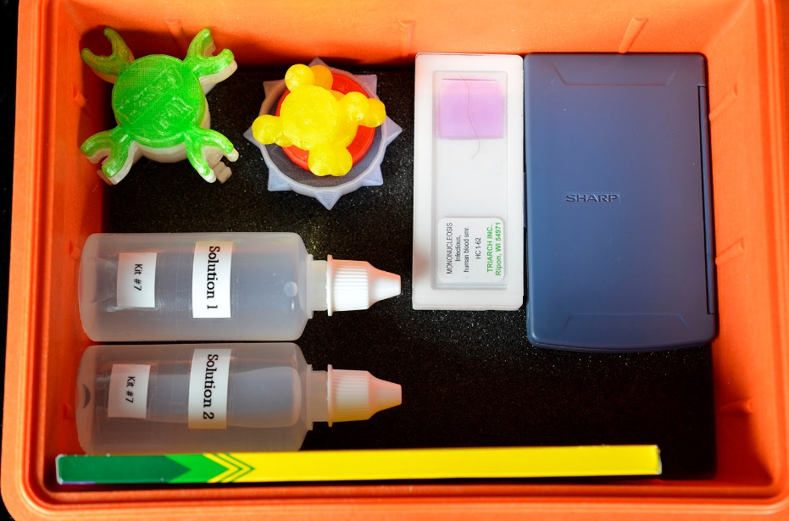

1. Put the microscope on top of the calculator and add the Sickness Indicator bottle, vials and pipets as shown.

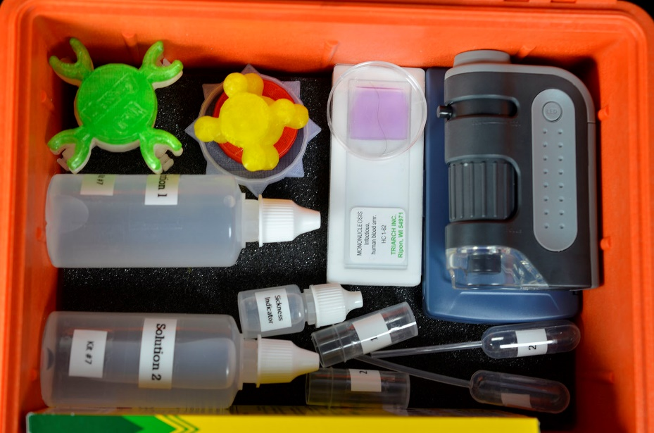

1. Place the cloth bag with the microbe cards inside on top of everything – make sure the drawstrings are not hanging outside of the case!

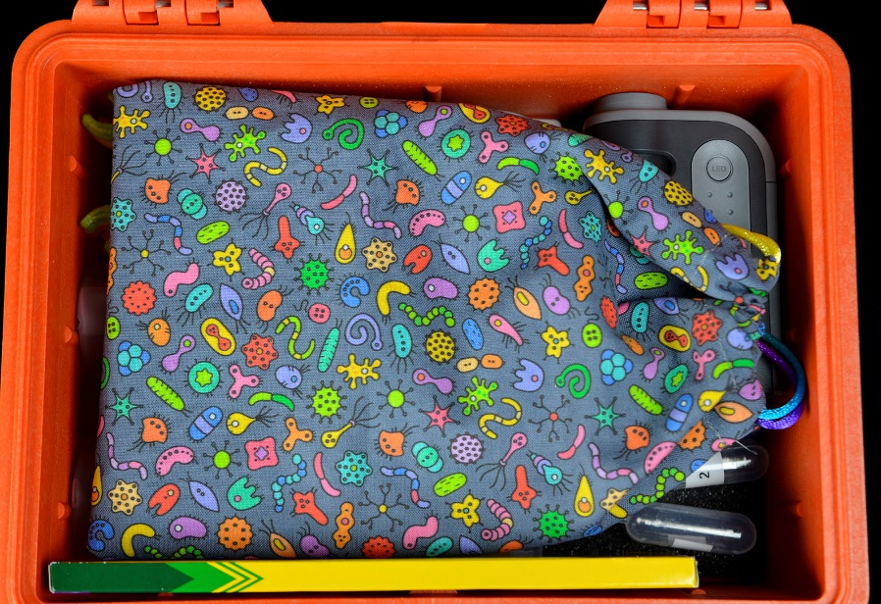

1. 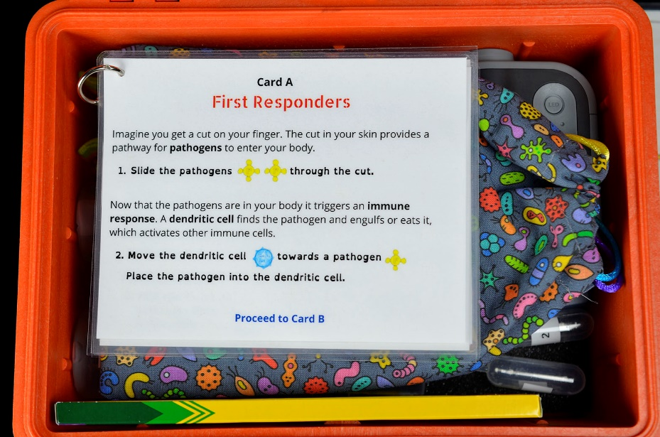Place the Immune Response cards on top of the cloth bag.
2. 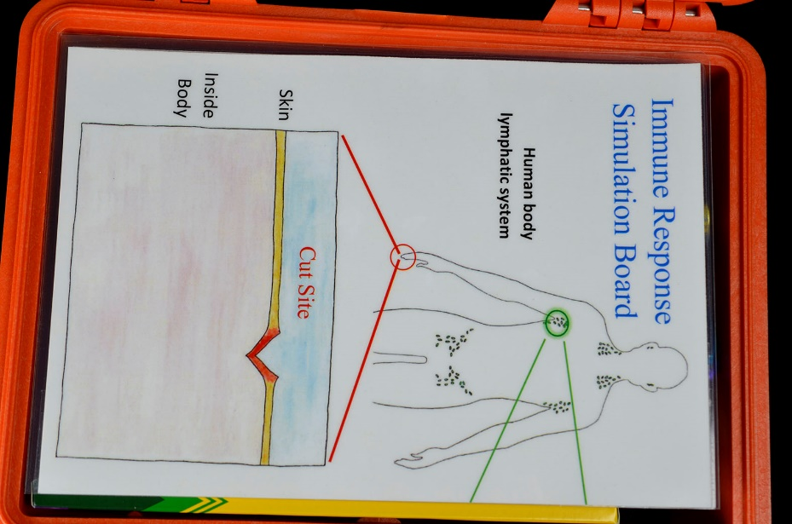Place the Immune Response Simulation Board on top of the cards – make sure it is completely inside the box.
3. Lastly, place the Going Viral booklet on top and carefully close the lid without pinching any of the items. CAUTION: Do not force the case shut – it should close with ease!

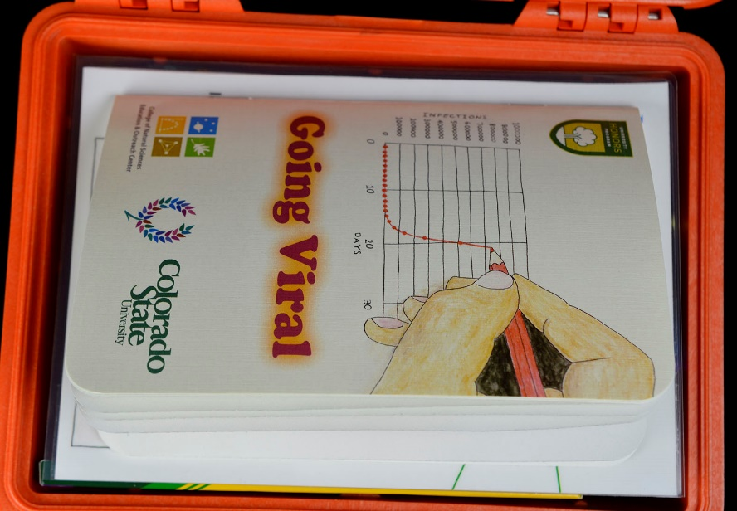

**Class Discussion Questions**

Note: The questions provided below are guide questions that you can include in a class discussion to help determine what students learned/took away from the kit.

**Part 1: Germs**

1. What is the difference between the terms microbe and pathogen?

*A microbe is any organism too small to see with the naked eye. There are many beneficial microbes. A pathogen is a general term for any microbe that causes disease.*

1. Why are scientists who study disease transmission interested in saliva?

*One way for a pathogen to spread is through saliva. When someone sneezes or coughs, they launch tiny droplets of saliva and mucus into the air. These saliva droplets act as a shuttle for the pathogen to catch a ride to another person.*

1. Only one “human” started infected in the activity. You only exchanged saliva with 3 other groups. Explain how the percentage of infected people can be so high when only one group was infected to begin with.

*The infected human spread the infection to 3 others. Once those got were infected, they each had the opportunity to spread the infection to 3 more human, quickly spreading the disease to 9 or more with just one level of exchange.*

1. How would you go about tracking down the one team that was infected in the beginning of the activity?

*This is called contact tracing. Scientists talk to each infected person and find out where they have been during the time they were most likely infected. Then, they go to that place, and find out who else was there during that time, and try to track down all those people to see if they were infected. In this manner, they can trace the outbreak back to its source.*

**Part 2: How Invisible Are Microbes?**

1. Do you think you would be able to see a virus using the microscope in the kit? Explain. *Since viruses are about 10- 100 times smaller than bacteria, and bacteria are about 10 times smaller than the red blood cells on the slide, it would not be possible to see viruses with this microscope. About one hundred small viruses would fit across the width of one red blood cell!*

**Part 3: Effects of Microbes**

1. Compare and contrast bacteria, viruses and eukaryotes.

Use the information gathered in the sorting to activity (shape, size, structure, and use) to make a comparison of the three kinds of microbes.

|  |  |  |  |
| --- | --- | --- | --- |
| *Characteristic* | Bacteria | Virus | Eukaryote |
| *Size* | Mid-sized (1000 nm) | Smallest (100 nm) | Largest (10,000+ nm) |
| *Shape* | Tend to be round or oblong, some spirals | Always have protein spikes; shape varies | Extremely variable |
| *Helpful or harmful* | Some helpful, some harmful | Viruses cannot replicate without taking over another cell so they are mostly harmful. However, there are several viruses that have symbiotic relationships with their hosts. Some are used in medicines and to develop vaccines. | Some helpful, some harmful |

**Part 4: Immune Response**

1. Explain what the difference is between T cells and Memory cells?

*T cells are first responder cells. They learn to recognize the specific pathogen and kill it. Memory cells are built during the first exposure to the pathogen. If you are exposed to the pathogen a second time, the memory cells attack instantly, and your body does not have to wait to build up its army.*

1. How does the immune response change when your body builds memory cells. Use your graphs to explain.

*The graphs show the response to the disease is swifter and stronger if memory cells are present.*

1. How does the shortened response time with memory cells help prevent the spread of the disease?

*If your body can kill the pathogen quickly, then when you are in contact with other people, you are not carrying the pathogen to them, and they won’t be carrying it to others after you.*

1. Explain what a vaccine is and how it works.

*A vaccine is an inactivated pathogen or an mRNA code from the pathogen that stimulates your body to produce a piece of the pathogen. The inactivated pathogen or mRNA generated spike proteins are not capable of causing disease but simply train your body to fight future infections by triggering the same immune response that an active, naturally occurring pathogen does by producing vital memory cells. A vaccine is simply a safe way to prepare your immune system to deal with encountering a pathogen by teaching your memory cells to recognize that pathogen without risking the chance of getting the disease.*

**Part 5: Herd Immunity**

1. How did the introduction of the vaccine change the spread of the virus? Use your data to explain.

*Data will vary, but there should be a significant decrease in the number of infected people in this second trial. If someone with a vaccine is exposed to the pathogen, their body has a chance to kill it before they infect someone else. Therefore, the spread of the virus is contained*.

1. What is herd immunity and why is it important?

*Herd immunity is when enough people are vaccinated that the pathogen cannot spread throughout the population. Enough people are immune that the pathogen does not find new people to infect. This is important because some people cannot get the vaccine because they are too young, too old, too weak or sick, or they have other health problems that prevent them from being vaccinated. If everyone who CAN get a vaccine DOES get a vaccine, then the people who cannot get the vaccine are much less likely to come in contact with the pathogen. Herd immunity keeps the unvaccinated more safe.*

**Sodium Hydroxide Solution 0.3 M – 6.0 M Safety Data Sheet Information**

See full SDS at:

<https://www.flinnsci.com/sds_735-sodium-hydroxide-solution-0.3-m---6.0-m/sds_735/>

**Hazard Class:**

* Skin corrosion or irritation (Category 1).
* Causes severe skin burns and eye damage (H314).
* Do not breathe mist, vapors or spray (P260).

**First Aid Measures:**

* Immediately call a POISON CENTER or physician (P310).
* **If inhaled:** Remove victim to fresh air in a position comfortable for breathing (P304+P340).
* **If in eyes:** Rinse cautiously with water for several minutes. Remove contact lenses if present and easy to do so. Continue rinsing (P305+P351+P338).
* **If on skin or hair:** Immediately remove all contaminated clothing. Rinse skin with water (P308+P361+P353).
* **If swallowed:** Rinse mouth. Do NOT induce vomiting (P301+P330+P331).

**Accidental Release Measures:**

* Ventilate area.
* Contain spill with sand or absorbent material; deposit in sealed bag or container.
* Absorb spills to prevent material damage (P390).

**Personal Protection:**

* Wear protective gloves, protective clothing and eye protection (P280).
* Wash hands thoroughly after handling (P264).

**Disposal considerations:**

* Please review all federal, state and local regulations that may apply before proceeding.
* Flinn Suggested Disposal Method #10 is one option.
* *Because we are using such small quantities and concentrations of NaOH, it is okay to wash down the sink with water as long as the school is connected to a sanitary sewer system and not into a septic system or storm sewer.*

**Phenolphthalein Alcohol Solution Safety Data Sheet Information**

See full SDS at:

<https://www.flinnsci.com/sds_592-phenolphthalein-alcohol-solution/sds_592/>

**Hazard Class:**

* Flammable liquids (Category 2).
* Highly flammable liquid and vapor (H225).
* Keep away from heat, sparks, open flames, and hot surfaces. No smoking (P210).
* Acute toxicity, oral (Category 4).
* Harmful if swallowed (H302).
* Do not eat, drink or smoke when using this product (P270).
* Skin and serious eye damage, corrosion or irritation (Category 2, 2A).
* Causes skin and serious eye irritation (H315+H319).

**First Aid Measures:**

* **If exposed or concerned:** Get medical advice or attention (P308+P313).
* **If inhaled:** Remove victim to fresh air and keep at rest in a position comfortable for breathing (P304+P340).
* **If in eyes:** rinse cautiously with water for several minutes. Remove contact lenses if present and easy to do so. Continue rinsing (P305+P351+P338).
* **If eye irritation persists:** Get medical advice or attention (P337+P313).
* **If on skin or hair:** Immediately remove all contaminated clothing. Rinse skin with water (P3030+P31+P353).
* **If swallowed:** Rinse mouth. Call a POISON CENTER or physician if you feel unwell (P302+P301+P312).

**Accidental Release Measures:**

* Remove all ignition sources and ventilate area.
* Contain the spill with sand or other inert absorbent material and deposit in a sealed bag or container.

**Personal Protection:**

* Wear protective gloves, protective clothing and eye protection (P280).
* Wash hands thoroughly after handling (P264).

**Disposal considerations:**

* Please review all federal, state and local regulations that may apply before proceeding.
* Flinn Suggested Disposal Method #18a is one option.
* *Because we are using such small quantities and concentrations of Phenolphthalein, it is okay to wash down the sink with water as long as the school is connected to a sanitary sewer system and not into a septic system or storm sewer.*

**Buffer Solution pH 2.0 Safety Data Sheet**

See full SDS at:

<https://www.flinnsci.com/sds_143-buffer-solution-ph-2.00/sds_143/>

**Hazard Class:**

* Acute toxicity, oral, dermal and inhalation (Category 5).
* May be harmful if swallowed, inhaled or in contact with skin (H303+H313+H333).
* Skin and serious eye damage, corrosion or irritation (Category 2, 2B).
* Causes skin and eye irritation (H315+H320).

**First Aid Measures:**

* Call POISON CENTR or physician if you feel unwell (P312).
* **If inhaled:** Call a POISON CENTER or physician if you feel unwell (P304+P312).
* **If in eyes:** Rinse cautiously with water for several minutes. Remove contact lenses if present and easy to do so. Continue rinsing (P305+P351+P338).
* **If eye irritation persists:** Get medical advice or attention (P337+P313).
* **If on skin:** Wash with plenty of water (P302+P352).
* **If skin irritation occurs:** Get medical advice or attention (P332+P313).
* **If swallowed:** Rinse mouth. Call and POISON CENTER or physician if you feel unwell (P302+P301+P312).

**Accidental Release Measures:**

* Ventilate area and contain the spill with sand or other inert absorbent material, neutralize with sodium bicarbonate or calcium hydroxide, and deposit in a sealed bag or container.

**Personal Protection:**

* Wear protective gloves, protective clothing and eye protection (P280).
* Wash hands thoroughly after handling (P264).

**Disposal considerations:**

* Please review all federal, state and local regulations that may apply before proceeding.
* Flinn Suggested Disposal Method #26b is one option.
* *Because we are using such small quantities and concentrations of Phenolphthalein, it is okay to wash down the sink with water as long as the school is connected to a sanitary sewer system and not into a septic system or storm sewer.*