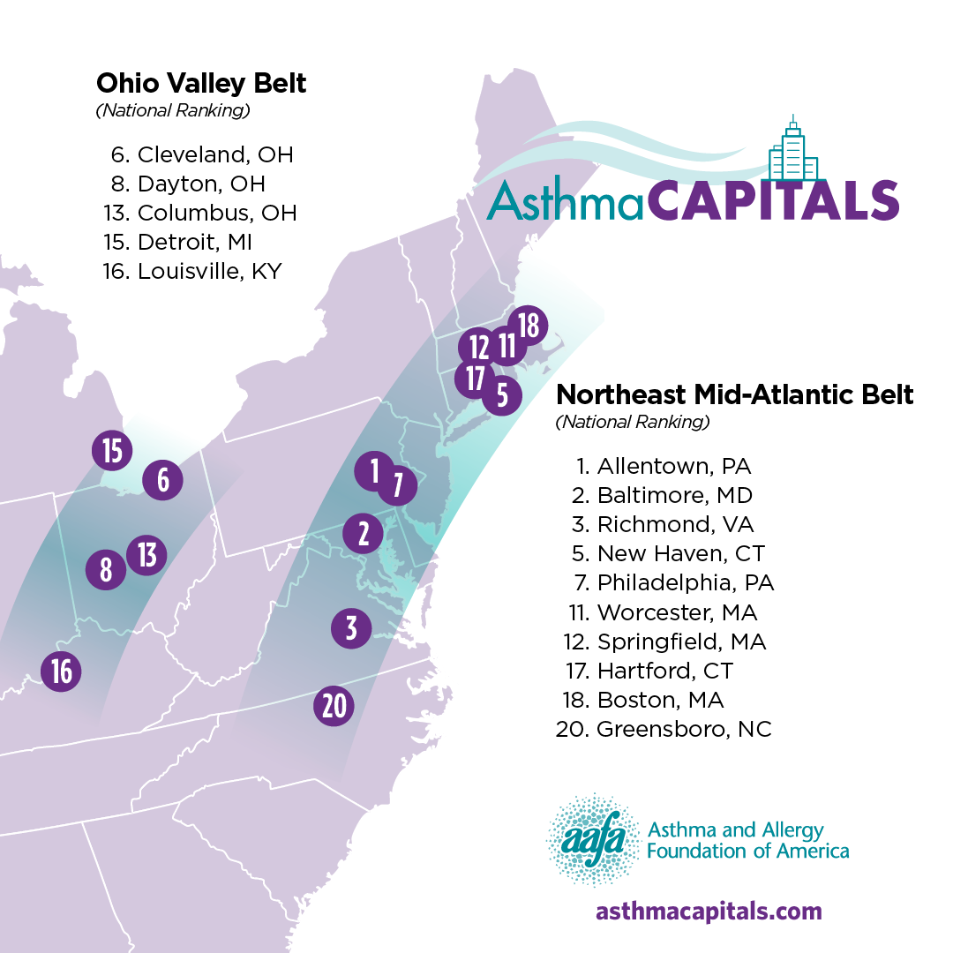
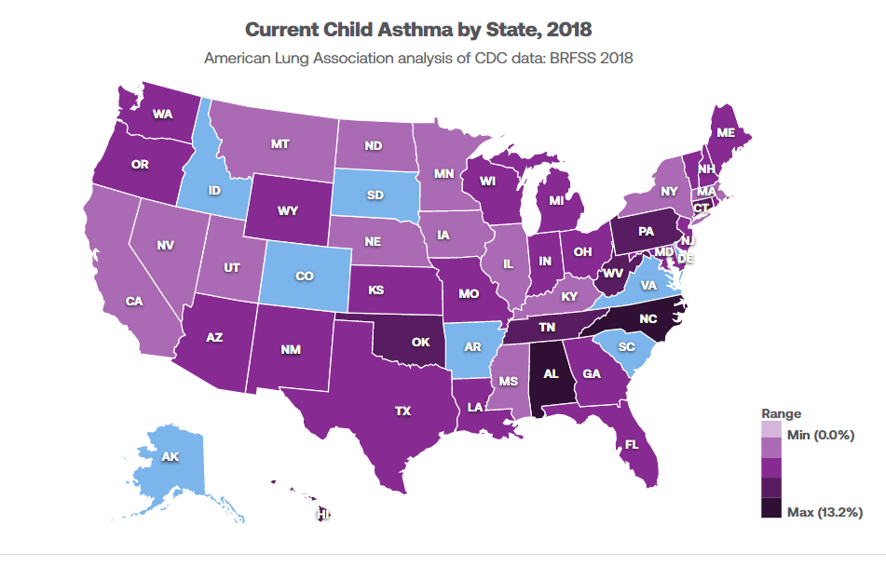

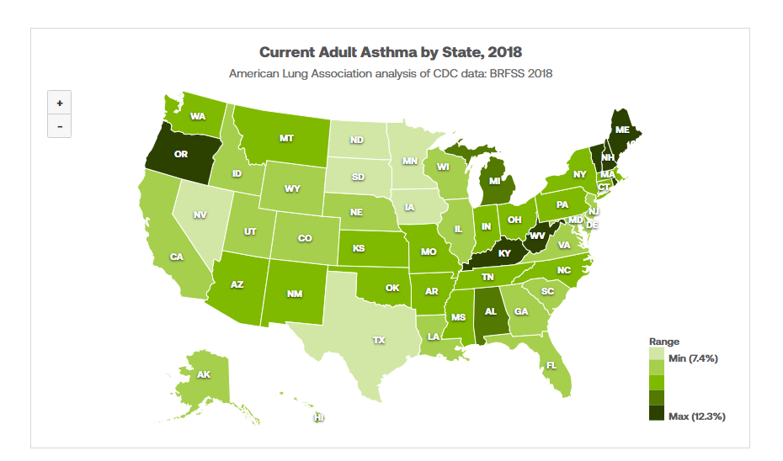
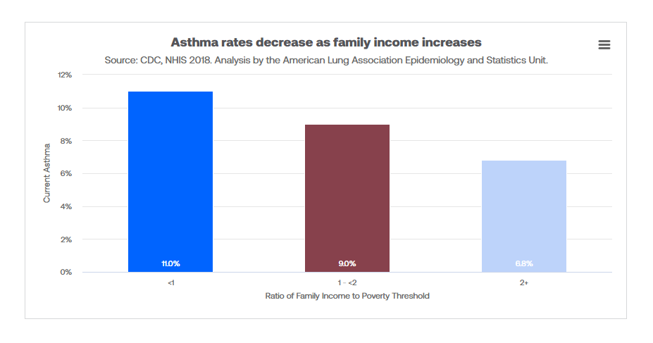
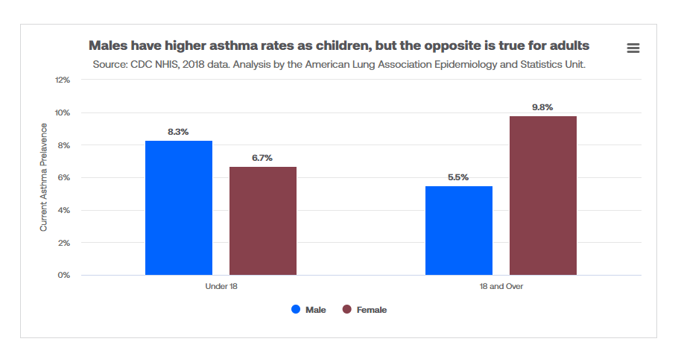

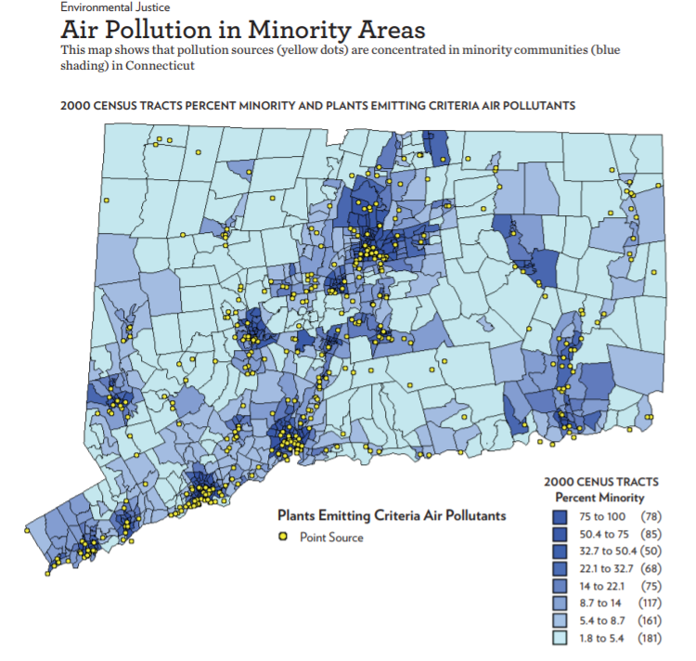
Map from Teaching Tolerance

https://portal.ct.gov/-/media/Departments-and-Agencies/DPH/dph/hems/asthma/gis/October2020/HospEd1418_2017PM25.pdf

https://portal.ct.gov/-/media/Departments-and-Agencies/DPH/dph/hems/asthma/gis/October2020/HospEd1418_2017NOx.pdf

https://portal.ct.gov/DPH/Health-Education-Management--Surveillance/Asthma/Asthma-Surveillance---GIS
https://www.lung.org/research/trends-in-lung-disease/asthma-trends-brief/current-demographics

https://healthmatch.io/blog/asthmas-worrying-trend-and-why-climate-change-is-the-culprit
https://ehp.niehs.nih.gov/doi/pdf/10.1289/ehp.7724

https://www.cdc.gov/asthma/data-visualizations/prevalence.htm#anchor_1569597996013

https://www.thelancet.com/journals/lanplh/article/PIIS2542-5196(19)30241-4/fulltext

